KUMASULIRA KWA MALAMULO OLIMBIKITSA KUSASIYANA PA MAUFULU AMAYI NDI ABAMBO KU MALAWI

1.Mawu oyamba 4
2.Cholinga cha malamulo oteteza maufulu amayi ndi asungwana 5
3.Malamulo oteteza maufulu amayi ndi asungwana 5
4. Malamulo akulu a dziko la Malawi (Constitution) 6
5. Lamulo lothana ndi nkhanza za pabanja kapena zapanyumba (Prevention of Domestic Violence Act) 16
5.1 Cholinga chalamuloli 16
5.2 Nkhanza zoletsedwa ndi lamulo 16
5.3 Mitundu yankhanza yoletsedwa pabanja kapena panyumba. 16
6. Chitetezo kapena thandizo lopelekedwa kwa anthu ochitiridwa nkhaza pabanja kapena panyumba 18
6.1 Thandizo la chitetezo (Protection Order) 19
6.2 Kodi angakadandaule ku bwalo la milandu ndi ndani? 21
6.3 Kodi chitetezo cha mathandizo chimatengedwa motani kubwalo lamilandu? 21
6.4 Chilamulo chotulutsa munthu wankhanza m’nyumba yake ndikusiyamo ochiltilidwa nkhanza 22
6.5 Kodi ndi ndani angakapemphe chitetezo cholamula kuti munthu wankhanza asamuke m’nyumba? 22
6.6 Chilamulo chotulutsa munthu wankhanza m’nyumba yobweraka ( yapa lendi) ndikusiyamo ochitiridwa nkhanza 23
6.7 Mathandizo ena amene bwalo lamilandu lingapereke kwa odadandaula 24
6.8. Kuwonetsetsa kuti zilamulo za bwalo lamilandu zikutsatidwa 24
6.9 Audindo owonetsetsa kuti lamulo lothana ndi nkhaza za pabanja likutsatidwa 24
6.10 Kulonjeza kukhala wakhalidwe labwino 25
6.11 Udindo okadandaulankhani zankhanza m’mabanja 26
6.12. Kupilila nkhanza sichiletso chokandandaula ku bwalo la milandu 26
6.13. Kodi ndi anthu ati amene angamvetsera milandu yankhani za nkhanza kubwalo lamilandu 26
6.14. Kuletsa kuwulutsa milandu ya khudzana ndi nkhanza za pabanja kapena panyumba 27
6.15. Ulangizi ndi uphungu 27
6.16. Kusakhutitsidwa ndi chigamulo cha bwalo lamilandu 28
7. Lamulo logawa ndi kuteteza chuma chamasiye (Deceased Estates (Wills, Inheritance and Protection) Act. 28
7.1 kulemberatu ndondomeko ya m’mene chuma chizagawidwire mwini chumayo akadzamawalira (kupanga Will). 30
7.2 Kodi Will imapangidwa motani? 30
7.3 Mboni zosayinira Will 31
7.5 Kodi Will ikhoza kusingidwa kuti? 32
7.6 Kuwononga kapena kusintha Will 32
7.7 Zotsatira pa ukwati kapena kutha kwa banja 32
7.7.1 Kuteteza mwamuna kapena mkazi otsala pabanja 33
7.8 Mkazi, mwamuna, ndi ana osagawilidwa katundu mu Will ya Malemu 33
8. Chuma chamalemu amene sanasiye ndondomeko yakagawidwe ka chuma chake 34
8.1 Kagawidwe ka katundu opanda Will 35
8.2 Kagawidwe ka chuma pamene malemu wasiya akazi angapo ba panja 36
8.3 Kodi mkazi kapena mwamuna otsala angakwatiwenso atalandira chuma cha masiye? 36
8.4 Kodi malemu ngati sanasiye mkazi, mwamuna, ana kapena makolo, katundu amagawidwa motani? 36
8.5 Mphamvu za bwalo la milandu lalikulu(High Court) pa nkhani za chuma chamasiye 37
8.6 Mphamvu za bwalo lamilandu laling’ono (Magistrate Court) pankhani zokhudzana ndi chuma chamasiye. 38
8.7 Kuteteza chuma chamasiye kuti chisawonongeke 38
8.8 Zufunika kuchita kuti anthu alandire katundu wogawidwa ndi will 38
8.9. Kodi munthu akamwalira osasiya Will choyenera kuchita ndi chani kuti katundu wamasiye agawidwe? 39
8.10. Kuchotsa pa udindo anthu ogawa ndi kuyanganira chuma cha masiye 40
8.11. Kagawidwe ka katundu wamasiye wosaposera K1,000,000 40
8.12 Kagawidwe ka malo amene ali ndi makalata aboma 41
8.13. Kagawidwe ka ndalema zamasiye zosiyidwa ku banki, kuboma, kapena kubwalo lamilandu. 41
8.14. Udindo wa anthu ogawa ndi kuyang’anira chuma cha masiye. 42
8.15. Milandu yokhudzana ndi chuma cha masiye 43
8.16. Malipilo apantchito a malemu 43
8.17. Okupha Malemu sakuyenera kulandira chuma chamasiye 44
9. Lamulo lothetsa kusalana mu maufulu pakati pa amayi ndi abambo (The Gender Equality Act) 44
9.1 Zolinga za lamulo la Gender Equality 44
9.2 Kuletsa kupondelezana pakati pa amayi ndi abambo 45
9.3 Kuletsa ndi Kuthana ndi makhalidwe oyipa 46
9.4 Kuletsa nkhanza ndi chitonzo pa nkhani zachisembwerendi zogonana 47
9.5 Udindo wa boma pothana ndi nkhanza ndi chitonzo pa nkhani zachisembewere ndi zogonana mu malo ogwira ntchito. 47
9.6 Udindo wa olemba anthu ntchito pothana ndi nkhanza ndi chitonzo pa zogonana ndi zachisembwere pa malo antchito. 47
9.7 Udindo wa bungwe la Malawi Human Rights Commission 48
9.8 Kulembedwa ntchito ku Boma. 48
9.9 Chilungamo pakalembedwe ka anthu apa ntchito ku boma ndi mabungwe aboma. 49
9.10 Maphunziro 50
9.11 Mwayi wachithandizo cha ndalama zolipilila sukulu 50
9.12. Ufulu wa uchembele wabwino komanso kugonana kwabwino 51
9.13 Udindo wa anthu ogwira ntchito zachipatala ndi za umoyo pa zaufulu wa uchembele wabwino ndi kugonana kwabwino 52
10. Lamulo lolemba anthu pantchito (Employment Act) 52
10.1 Kuletsa tsankho pa malo antchito 53
10.2 Zoyenera kugwiilizana polembedwa ntchito 53
10.3 Tchuthi cha amayi amene angobereka kumene 54

1.Mawu oyamba
Dziko la Malawi lidalonjeza potsatira zomwe mayiko osiyana siyana anagwirizana poteteza maufulu a amayi and asungwana. Motsatana ndi lonjezoli, boma la Malawi linakhazikitsa ma lamulo oteteza maufulu a amayi ndi a sungwana. Malamulo amenewa ndi monga: Constitution (malamulo akulu a dziko la Malawi), Gender Equality Act (lamulo lothetsa kupondelezana mmaufulu pakati pa amayi andi abambo), Deceased Estates (Wills, Inheritance and Protection) Act (lamulo logawa chuma cha masiye) , ndi Employment Act (lamulo lokhudzana ndi olemba ndi olembedwa pa ntchito).
Ngakhale malamulo amenewa anakhazikitsidwa pa kanthawi, vuto ndilakuti anthu ambiri sadziwa kapena samvetsetsa za malamulo amenewa.Pa zifukwa zimenezi, malamulo amenewa atanthauzilidwa mchiyankhulo cha Chichewa ndi cholinga choti anthu ambiri athe kudziwa ndi kumvetsetsa za malamulowa.

2.Cholinga cha malamulo oteteza maufulu amayi ndi asungwana
Malamulo oteteza maufulu amayi ndi asungwana anakhazikitsidwa pozindikira kuti, amayi ndi asungwana akhala akupondelezedwa mmamaufulu awo poyelekeza ndi abambo ndi anyamata. Izi zakhala zikuchitika motere chifukwa cha miyambo ndi zikhalidwe za mitundu ya anthu osiyanasiyana ku Malawi imene imakondela abambo ndi anyamata pa zinthu zambiri. Miyambo ndi zikhalidwe zimenezi zakhalanso zikupititsa patsogolo mchitidwe wa nkhaza kwa amayi ndi asungwana.
Pofuna kuthana ndi ziphinjo zomwe amayi ndi asungwana akhala akukumana nazo pa moyo wawo, boma linakhazikitsa malamulo owonetsetsa kuti pasakhale kusiyana pa maufulu amuna ndi akazi. Mwazina cholinga chamalamulowa ndi:
- Kuwonetsetsa kutiamuna andi akazi akukhala mwa ufulu ofanana mogwirizana ndi malamulo a dziko la Malawi;
- Kuteteza amuna ndi akazi ku nkhanza za m’banja kapena panyumba;
- Kuwonetsetsa kuti amuna ndi akazi akutenga mbali mofanana pa moyo wawo ndi poyendetsa dziko;
- Kuwonetsetsa kuti amuna ndi akazi ali ndi mwayi ofanana opeza zinthu zimene zimapelekedwa ndi boma;
- Kuthana ndi kusalana ndi kuponderezana pakati pa akazi ndi amuna
- Kuthana ndi miyambo kapena zikhalidwe zolakwika zosagwilizana ndi malamulo a dziko, imene imapondereza amuna kapena akazi.

3.Malamulo oteteza maufulu amayi ndi asungwana
Malamulo amene ali ndimfundo zoteteza maufulu amayi ndi asungwana komanso kuwonetsetsa kuti amuna ndi akazi ali ndi maufulu ofanana mogwilizana ndi malamulo ndi awa:
- Malamulo akulu adziko la Malawi (Constitution),
- Lamulo lothetsa kupondelezana mu maufulu pakati pa amayi ndi abambo (Gender Equality Act)
- Lamulo logawa chuma cha masiye (Deceased Estates (Wills and Inheritance Protection) Act ) ,
- Lamulo lokhudzana ndi olemba ndi olembedwa pa ntchito ( Employment Act)
- Lamulo lothana ndi nkhanza za pabanja kapena zapanyumba (Prevention of Domestic Violence Act)

4. Malamulo akulu a dziko la Malawi (Constitution)
4.1 Constitution ndi muzu komanso malamulo akulu ku Malawi amene anakhazikitsidwa mu chaka cha 1994. Malamulo onse, miyambo, zikhalidwe, mfundo ndi zigamulo zonse za boma kapena anthu ziyenera kugwilizana ndi mfundo zimene zili mu Constitution. Malamulo, miyambo, zikhalidwe, mfundo ndi zigamulo za boma kapena za anthu zimene zikutsutsana ndi zimene zili mu Constitution ndi zopanda mphamvu ina iliyonse ndipo sizikuyenera kutsatidwa.
4.2 Constitution inachilikizika pangodya zingapo. Imodzi mwangodyazi ndi yotsimikiza kuti anthu onse ndi ofanana pa lamulo. Izi zikutanthauza kuti maufulu achibadwidwe a munthu akuyenera kukhala ofanana pakati pa anthu ena onse posatengera kuti munthu ndi:
(a) mkazi kapena wa mwamuna;
(b) olumala kapena osalumala,
(c ) wapabanja kapena wopanda banja,
(d ) wamtundu wosiyana ndi ena;
(e ) wachilankhulo chosiyana ndi ena
(f ) wachipembedzo chosiyana ndi ena; kapena
(g ) wosiyana ndi anthu ena mnjira zosiyanasiyana.
(Insert Photo of Graduation/Grandparents, not sure)
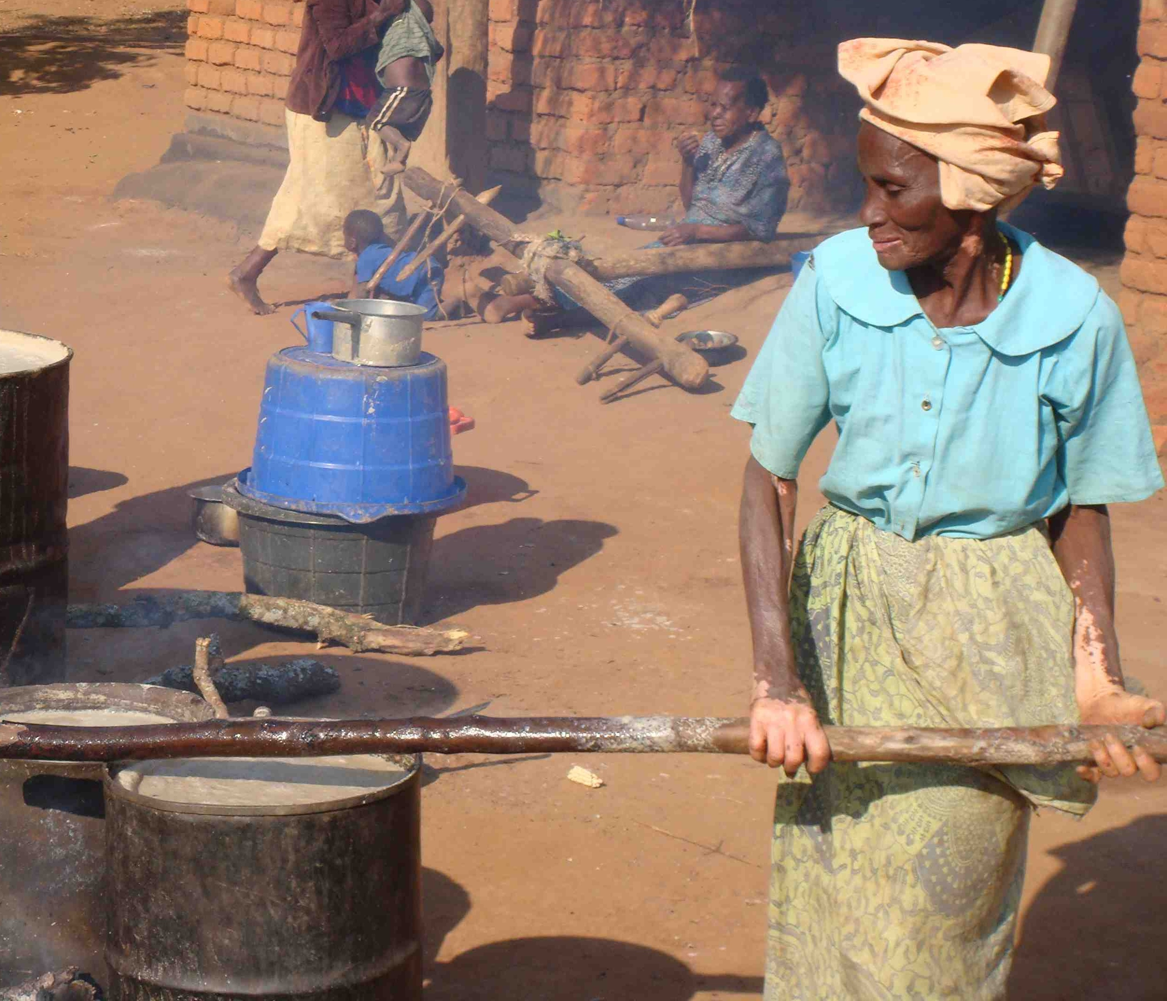

4.3 Munthu aliyense ali ndi maufulu achibadwidwe ofanana ndipo maufulu amenewa akhoza kuchepetsedwa mokhudzana ndi lamulo ndi cholinga choti anthu akhale mwabata, mololelana ndi mwaufulu pagulu.

4.4 Constitution imalamula kuti munthu aliyense ali ndi undindo kwa anthu ena, ku banja lake, kumalo kumene akukhala ndi mdziko. Maufulu amene anthu ali nawo sakuyenera kuphwanya maufulu a anthu ena. Ufulu uliwonse ulinso ndi udindo wake.Izi zili choncho chifukwa lamulo limazindikira kuti munthu amayenera kukhala ndi anthu ena ku malo osiyanasiyana.Ena mwa maudindo amene munthu ali nawo ndi awa: (insert picture of chief holding a meeting)
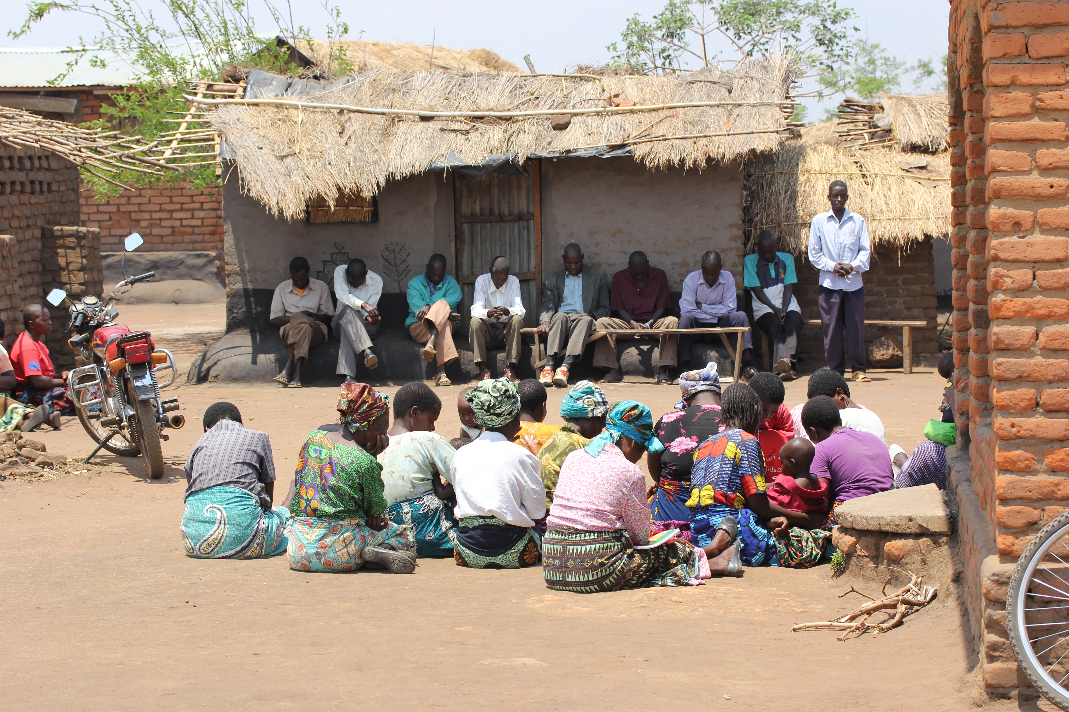

- udindo olemekeza anthu ena mosasankhana kapena kusalana;
- udindo okhala ndi anthu ena mwabata komanso mololelana;
(c ) udindo ogwilitsa maufulu moganizila anthu ena, chitetezo chadziko, zolinga za anthu mogwilizana ndi chikhalidwe cholongosoka.

4.5 Ma udindo amenewa anakhazikitsidwa mu Constitution ndi cholinga choti amuna ndi akazi azikhala mwa ufulu, mwamtendere komanso mwa bata.

4.6 Constitution imalamula boma kuti likhazikitse ndondomeko , malamulo ndi ngodya zowonetsetsa kuti amuna andi akazi asamasiyane pa maufulu ndi ntchito zosiyanasiyana zokhudza miyoyo yawo. (insert picture of soldiers/police/doctors)
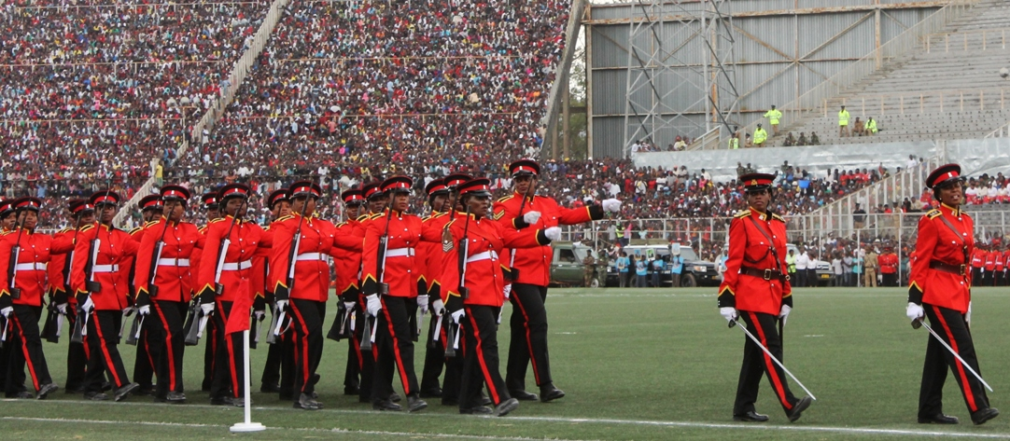

4.7 Constitution imapeleka komanso kuteteza maufulu kwa anthu onse mosatengera kuti munthu ndi mwamuna kapena mkazi. Ena mwa maufulu amene Constitution imapaleka ndi kuteteza ndi awa: -
(a) ufulu okhala ndi moyo komanso kusalandidwa moyo popanda chifukwa chovemerezeka ndi lamulo;
(b) ufulu okhala mwa mtendere
(c) ufulu olemekezedwa,kusanyozedwa ndi kukhala mwa umunthu;
(d ) ufulu osachitilidwa nkhaza,kapena chitonzo komanso kusalangidwa mwa nkhaza kapena mwa chitonzo;
(e) ufulu osalangidwa momenyedwa ngati chilango ku bwalo la milandu kapena kunthambi ina iliyonse ya boma;
(f) ufulu osapangidwa za kafukufuku za chipatala kapena ukatswiri osiyanasiyana popanda chilolezo cha mwini;
(g) ufulu osamangidwa popanda mlandu, osamangidwa chifukwa cha chipembedzo kapena maganizo, komanso osatsekeredwa kundende chifukwa chophwanya mapangano pakati pa anthu kapena ma bungwe.
(h) ufulu osafufuzidwa mthupi kapena muzovala, ndi m’nyumba yako popanda chifukwa kapena lamulo.
- Ufulu oti munthu wina asawerenge makalata, ma uthenga apa lamya kapena kumvera zolankhulana pa lamya popanda chilolezo cha mwini wake:

Komabe tiyenera kudziwa kuti a Polisi ali ndi mphamvu zofufuza katundu, panyumba kapena muzovala za munthu ngati ali ndi chilolezo chochokera ku bwalo la milandu (search warrant). Komanso akhoza kutero ngati akukhulupilira kuti katundu wabedwa kapena mlandu wina uliwonse wapalamulidwa ndi munthu.

(j) ufulu okwatira, kukwatiwa ndikukhala pabanja
(k) ufulu osakakamizidwa kukwatila kapena kukwatiwa
(l) ufulu wa munthu amene ali ndi zaka zakubadwa zokwana 18 kuti asaletsedwe kukwatiwa kapena kukwatila;
(m) ufulu wopanga maphunziro kapena kupita ku sukulu kukaphunzira;
(n) ufulu ogwilitsa ntchito chilankhulo chimene munthu akufuna komanso kutenga mbali muzikhalidwe za makolo kapena zimene munthu wasankha;
(o) ufulu osakakamizidwa kugwira ntchito kapena kukhala kapolo
(p) ufulu okhala ndi katundu komanso kupeza katundu mwawekha kapena ndi anthu ena. Palinso ufulu osalandidwa katundu mosatsata malamulo
(q) ufulu ogwira ntchito kapena kupanga malonda mwaufulu.

4.8 Kwa anthu amene ndi olembedwa pa ntchito, Constitution imalamula kuti anthuwa ayenera kulandira malipilo ofanana pa ntchito yofanana imene agwira. Sipayenera kusiyanitsa chifukwa chakuti munthu wina ndi mwamuna kapena mkazi kapena ndi wamtundu wina. Kuwonjezera apo munthu aliyense ali ndiufulu okhala mubungwe lomenyerera kapena kuteteza maufulu a anthu apantchito.

4.9 Munthu aliyense ali ndiufulu okhala m’mabungwe kapena misonkhano yosiyanasiyana. Komanso, munthu sakuyenera kukakamizidwa kukhala m’bungwe kapena misonkhano.

4.10 Munthu aliyense, mwamuna kapena mkazi, ali ndi ufulu onena zakhukhosi kwake komanso kufotokoza maganizo ake.

4.11 Constitution imapelekanso ufulu kwa munthu kukhala ndi chipembedzo kapena chikhulupililo mwa ufulu wake. Munthu sakuyenera kukakamizidwa kulowa chipembedzo kapena chikhulupiliro.

4.12 Munthu aliyense ali ndi ufulu wopeza mauthenga amene amasungidwa ndi boma ndi cholinga chogwilitsa uthengawo pa ufulu wachibadidwe.

4.13 Munthu aliyense ali ndi ufulu:
(a) wochita ziwonetsero ndi amnzake mwamtendere mosanyamula zida;

(a) wokhala ndi kuyenda m’dziko la Malawi, kuchoka mdziko la Malawi komanso kubwerera ku dzikoli.

4.14 Pa za ndale,Constitution imapeleka ufulu kwa munthu aliyense:
(a) wopanga chipani chandale, kulowa mchipani chandale , kutenga mbali mntchito za chipani chandale komanso kumemeza ndi kunyengelela anthu kuti alowe mchipani cha ndale;
(b) kufalitsa uthenga wachipani kapena mfundo zosiyanasiyana
(c) kutenga mbali mwa mtendere mu ntchito za chipani kapena za ndale ndi cholinga chosintha mfundo za boma kapena utsogoleri wa boma;
(d) ufulu osankha chipani kapena atsogoleri mosakakamizidwa
(e) ufulu opikisana pa mpando wa mphungu wa kunyumba ya malamulo, mpando wa maboma ang’ono komanso utsogoleri wa dziko lonse;
4.15 Munthu aliyense ali ndi ufulu okadandaula kubwalo lamilandu kapena mabungwe omva madandaula a anthu. Powonjezera apo munthu aliyense akuyenera kulandila thandizo pa madandaulo ake pamenene ufulu wake umene umapelekedwa ndi Constitution wa phwanyidwa. Zimenenzi ndi zotetezedwa ndi malamulo akulu adziko lino.
4.16 Constitution imapelekanso maufulu osiyanasiyana kwa munthu amene wamangidwa kapena kutsekeledwa ku ndende kamba koganiziridwa kuti wa palamula mulando oyimbilidwa ndi boma. Maufulu amenewa ali motere:-
(a) omangidwa aliyense ali ndiufulu odziwitsidwa mwamsanga chifukwa chimene wa mangidwira mchiyankhulo chimene omangidwa amamva.;
(b) omangidwa aliyense ali ndi ufulu osungidwa mmalo abwino, komanso kupatsidwa zolembera ndi zowerenga, zakudya zoyenera munthu, ndiponso kupatsidwa chithandizo chamankhwala pamene womangidwayo wadwala mundende. Izi ziyenera kuperekedwa ndiboma.;
(c) omangidwa aliyense ali ndiufulu okumana mwapadera ndi oyimila anthu pa milandu amene omangidwayo akufuna. Munthu omangidwa ayelenera kuuzidwa ndi apolisi kuti ali ndi ufulu umenewu komanso ngati alibe mwayi opeze omuyimila milandu wa kukhosi kwake, boma lili ndi udindo omupezera munthu omuyimilila mlandu amene akuyenera kulipidwa ndiboma;
(d) omangidwa aliyense ali ndi ufulu wolankhulana kapena kuwonedwa ndi abale ake, banja lake, mpingo, ndi dotolo wa kukhosi kwake;
(e ) omangidwa aliyense ali ndi ufulu wotsutsa kumangidwa kwake mwayekha kapena kudzela kwa omuyimila mlandu kubwalo la milandu;
(f ) omangidwa aliyense ali ndiufulu otulutsidwa mundende kapena kumasulidwa ngati kumangidwa ndi kutsekeledwa kwake ndi kosatsata malamulo adziko.

4.17 Komanso, munthu amene wamangidwa kapena oganiziridwa kuti wa palamula mlandu oyimbidwa ndi boma alinso ndi maufulu awa: -
(a) ufulu ouzidwa mwamsanga ndi apolisi kapena aboma kuti ali ndi ufulu osayankha zimene akufunsidwa komanso ayenera kuwuzidwa zotsatira ngati ayankhepo zimene wafunsidwa
(b) ufulu otengeredwa kubwalo la milandu pasanathe ma ola makumi anayi ndi mphambu zisanu ndi zitatu (48 hours) kuti akafotokozeredwe mlandu umene aboma akumuyimba komanso chifukwa chimene akusingilidwa kundende. Malamulo amalola kuti munthu omangidwa akhoza kutengeredwa ku bwalo la milandu patadutsa ma ola 48 pokhapokha ngati maola amenewa akukwana pa nthawi yoti ogwila ntchito kubwalo la milandu aweruka kapena ndi tsiku la tchuthi kapena ndi loweluka kapena lasabata. Ngati izi zili choncho munthu omangidwayu ayenera kutengeredwa kubwalo la milandu pa tsiku lotsatira masiku tatchulawa. Ngati munthu omangidwayu satengeredwa ku bwalo la milandu ayenera kutulutsidwa kundende komanso kumasulidwa.
(c) ufulu osakakamizidwa kuvomera mlandu kapena kuvomera zaumboni umene utha kugwiritsidwa ntchito momuyipila omangidwayo.;
(d) ufulu woyikidwa malo osiyina ndi amene akuseweza chilango, pokhapokha ngati pali zoletsa kutero. Omangidwa poganiziridwa mlandu ayenera kusungidwa mosiyana ndi amnene akuseweza chilango ku ndende.;
(e) ufulu otulutisdwa kundede mwaufulu kapena kutulutsidwa ndi mfundo zoyenera kutsatiridwa akatuluka kundende( bail). Omangidwa poganiziridwa mlandu sangathe kutulitsidwa ngati pali zifukwa zokwanira zoletsa kutulutsidwa kwa munthuyi.
(f) ufulu ozengedwa mlandu ku kubwalo la milandu laboma pagulu la anthu, pasanathe nthawi yayitali chimangidwire, mwachilungamo ndi mosakondera mbali.
4.18 Maufulu amu Constitution amaperekedwa kwa anthu onse, amuna ndi akazi. Komabe, Constitution imatsindika mugawo makhumi awiri ndi mphambu zinayi(24) kuti amayi kapena akazi akuyenera kudyerera maufulu onse amene ali mu Constitution. Mwa ichi Constitution ikunene mwatsatanetsatane kuti:
(1) Amayi ali ndi ufulu otetezedwa ndi lamulo ngati amuna.Komanso amayi sayenere kusalidwa kapena kupondelezedwa chifukwa choti ndi amayi kapena chifukwa choti ali pabanja kapena sali pabanja. Amayi alinso ndi maufulu awa:—
(a) kukhala ndi maaufulu onse amene lamulo limapeleka kwa munthu mwamuna monga:
(i) kulowa mumgwirizano wa zamalando ndi zantchito;
(ii) kupeza kapena kupata katundu mwa iwo okha kapena ndi anthu ena posatengera kuti ndi okwatiwa kapena osakwatiwa:
(iii) kusungu kapena kuyang’anira ana komanso kutengapo mbali pakaleledwe ka ana
(iv) kukhala mzika za dziko lino la Malawi.
4.19 Pamene banja latha amayi ayenera-
(i) kugawilidwa katundu amene anapeza limodzi ndi mwamuna wawo amene asiyana naye:
(ii) kupatsidwa chithandizo ngakhale banja latha potengera chuma chimene mwamuna wawo wakale ali nacho komanso poganizira ana amene anaberekedwa pa nthawi ya banja
4.20 Constitution imatsindikizanso kuti lamulo lillonse limene limasala kapena kupondereza amayi chifukwa choti ndi amayi kapena poti ndi okwatiwa kapena osakwatiwa, lilibe mphamvu ina iliyonse. Lamulo loteleri siliyenera kutsatidwa.
Kuwonjezera apo, Constitution imapeleka undindo kuboma la Malawi kuti likhazikitse malamulo othana ndi miyambo ndizikhalidwe zimene zimapondereza amayi. Miyambo ndizikhalidwezi ndi monga:
(a) Kuchitira nkhanza amayi mnjira zosiyanasiyana kuphatikizapo zogonana
(b) kusala amayi pa ntchito zosiyanasiyana, pamabizinesi , pantchito zolembedwa komanso pa moyo wa anthu watsiku nditsiku;
(c) kulanda amayi katundu wawo kuphatikizapo chuma chosiyiridwa ndi malemu
4.21 Pofuna kuthana ndi zikhalidwe kapena miyambo yopondereza amayi, boma linakhazikitsa malamulo osiyanasiyana ndicholinga choti maufulu amayi ndi asungwana akhale otetezedwa.Malamulo amene boma lakhazikitsa ndi monga awa:
(a) lamulo lothetsa kupondelezana mu maufulu pakati pa amayi ndi abambo (Gender Equality Act)
(b) Lamulo logawa chuma cha masiye (Deceased Estates (Wills, Inheritance and Protection) Act)
(c) Lamulo lokhudzana ndi olemba ndi olembedwa pa ntchito (Employment Act)
(d) Lamulo lothana ndinkhanza za pabanja kapena panyumba (Prevention of Domestic Violence Act)

(VACS report)

5. Lamulo lothana ndi nkhanza za pabanja kapena zapanyumba (Prevention of Domestic Violence Act)

5.1 Cholinga chalamuloli
Lamulo limeneli linakhazikitsidwa ndi boma ndi cholinga chofuna kuwonenetsetsa kuti nkhanza zochitika pakati pa amayi ndi abambo pabanja, pakati pa makolo ndi ana kapena osungidwa panyumba zathetsedwa. Lamuloli limapelekanso mathandizo osiyanasiyana kwa munthu amene wachitiridwa nkhanza pabanja kapena panyumba. Boma linazindikira kuti anthu ochitiridwa nkhanza panyumba kapena pabanja satha kudandawula za nkhanzazi komanso samapeza chithandizo choyenera akadandaula. Kawirikawiri nkhanza zikamachitika pabanja kapena panyumba, anthu adera samalowelerapo chifukwa amatiizi ndi za m’nyumba. Kotero kafukufuku anawonetsa kuti nkhaza za pabanja kapena za panyumba zimachuluka popeza panalibe lamulo lenileni lothana ndi nkhazazi.

5.2 Nkhanza zoletsedwa ndi lamulo
Lamuloli limafotokoza kuti nkhanza za mtundu wina uliwonse ndi zoletsedwa pabanja kapena panyumba . Nkhanzazi zikhoza kukhala zokhudzana ndi kumenyena ndi kuvulazana, kugonana, kuzunzana m’maganizo, kulandidwa chuma kapena ndalama, komanso kuletsedwakupeza mpata wopezera ndalama kapena chuma. Nkhanza zimenezi zimachitika pabanja kapena panyumba pakati pa mwamuna ndi mkazi kapena kholo ndi ana ake komanso anthu ena osungidwa pa khomo.
Lamulo lothana ndi nkhaza za pabanja ndi panyumba limatsata ma ubale ngati awa:
(a) pakati pa mwamuna ndi mkazi pabanja;
(b) pakati pa mwamuna ndi mkazi amene ali ndi mwana koma osakwatirana;
(c) kholo ndi mwana wake kapena wachibale wina aliyense osungidwa panyumba ya khololo
(d) pakati pa mwamuna ndi mkazi amene akhala pa chibwenzi choyenderana kosachepera miyezi khumi ndi iwiri (12):

5.3 Mitundu yankhanza yoletsedwa pabanja kapena panyumba.
Tawona kale kuti nkhanza zimachitika munjira zosiyanasiyana. Motero, lamulo limazindikira kuti nkhanza zili m’mitundu ingapo ngati iyi:
- Kupondereza munthu kuti asapeze chuma komanso kuti asathe kukhala odzithandiza mwayekha. Zitsanzo ndi monga kumukaniza munthu kuti asapange mabizinesi komanso kumukaniza mwayi wopeza makobidi opangila ma bizinesi; kumumana munthu pabanja kapena panyumba zithandizo zosiyanasiyana kuphatikizapo zakudya, zovala ndi malo ogona; kumukaniza munthu pabanja kuti asapeze ntchito yolembedwa; kusapeleka malipilo kwa munthu amene wagwira ntchito, komanso khalidwe lofuna kuti munthu wina wa pabanja kapena panyumba asakhale odzidalira ndi cholinga choti azingodalirabe munthu wina.

- Kuzunzana kapena kusawutsana m’maganizo ndi cholinga chofuna kusokoneza munthu. Zimenezi zimachitika munjira izi:
- kuwopseza munthu, kunyogodola munthu polankhula mawu otokuwana, olalata ndi owopseza;
(ii) Kumulondalonda munthu mowirikiza m’malo osiyanasiyana popanda chifukwa;

(iii) kumulanda munthu katundu wake kapena kumuletsa munthu kugwiritsa ntchito katundu wake;
(iv) kumulonda munthu popanda chifukwa kumalo ake ogwira ntchito, kumene amakhala kapena kumene amapangira mabizinesi
(v) Kuphwanya kapena kuwononga katundu wa mwini;
(vi) kumutsekela munthu munyumba popanda chikukwa kapena kumuletsa munthu popanda chifukwa kuti asayande kapen kuchoka pa khomo ;
(vii) Kumangoyimbira lamya la kuntchito kwa munthu mowirikiza popanda chifukwa. Komanso kumangomuyimbira munthu lamya yake mowirikiza popanda chifukwa:
(viii) Kuwopseza kapena kucheza mosalongosoka ndi mwana, wachikulire wachibale, kapena munthu osungidwa pabanja kapena pa nyumba
(c ) Nkhanza zokhudzana ndi kumenyana, kuvulazana, komanso kuchita kapena kusachita chinthu chimene chingavulaze munthu, kuchita, kapena kusachita chinthu chimene chingadzetse mantha kwa munthu wina kuti akhoza kuvulazidwa pa thupi.
(d ) Kuletsa munthu kuti asacheze ndi amnzake ndi cholinga choti azingocheza kapena kudalira munthu wina amene ali omuzunza; (insert photo of stop child marriage)

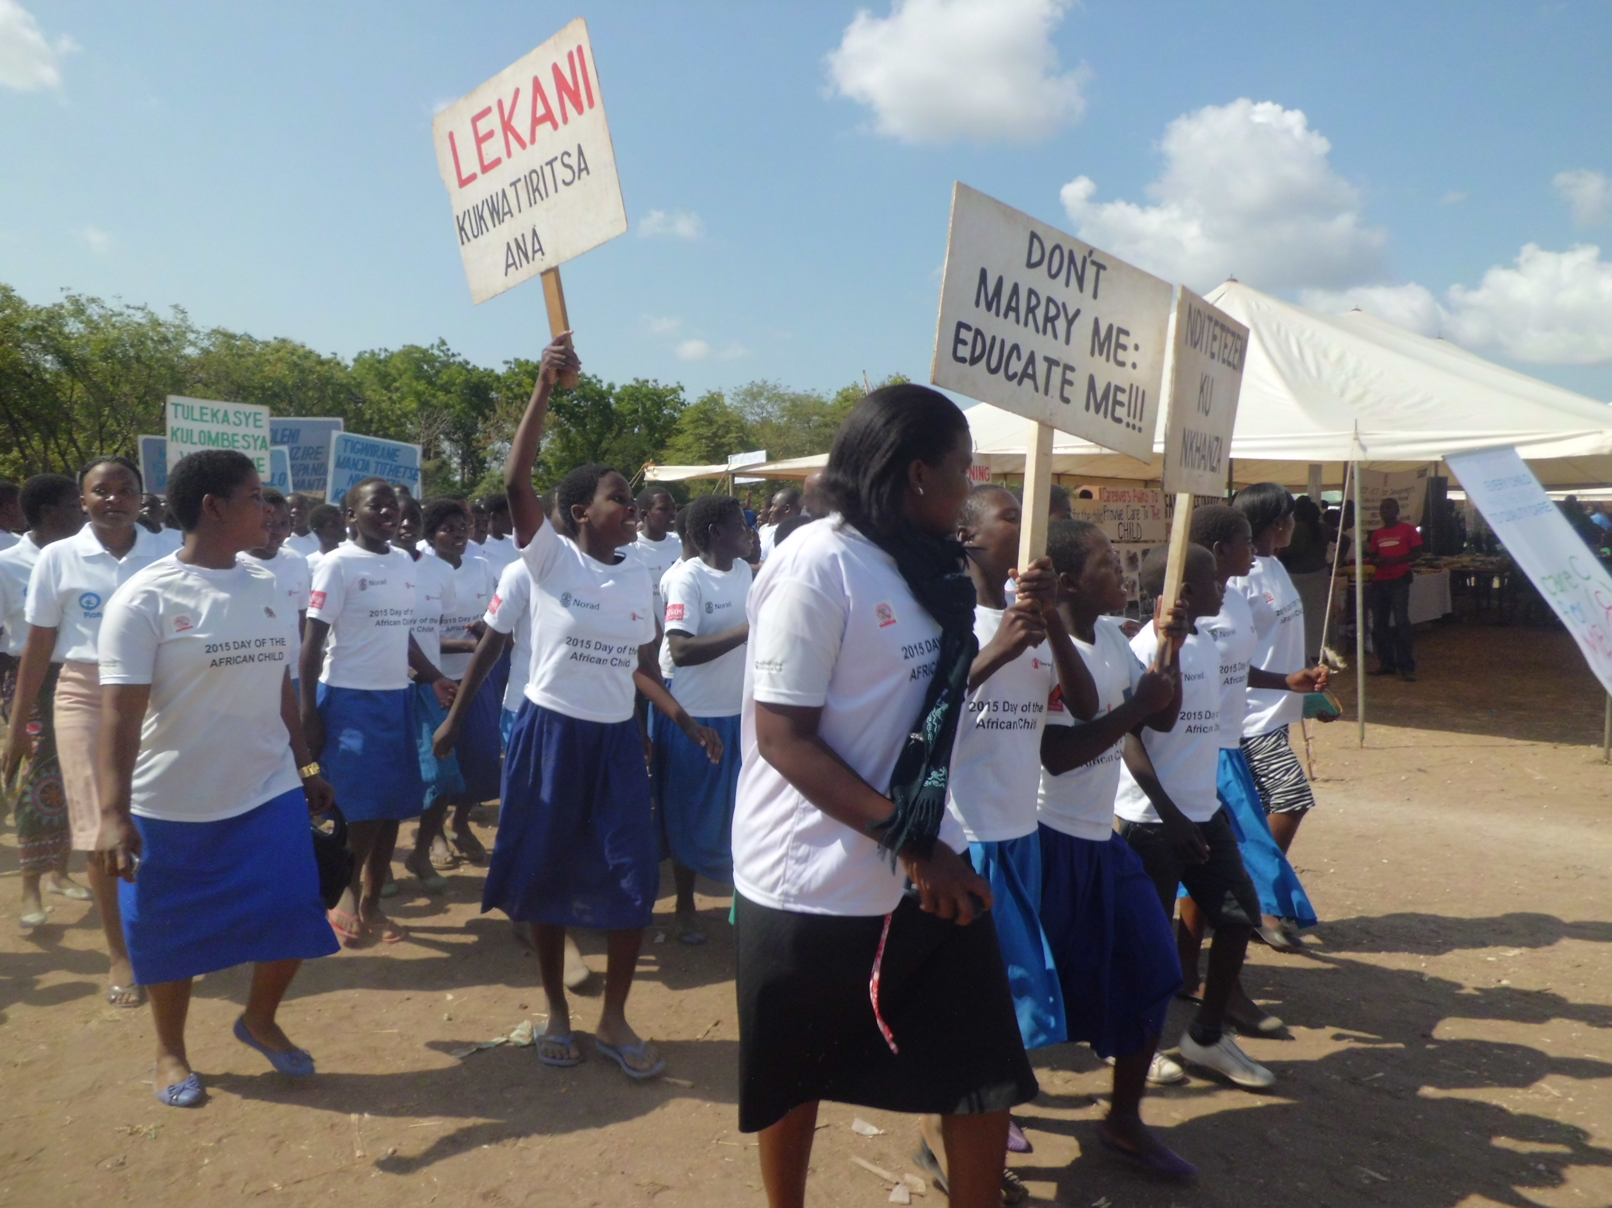
(e) Nkhaza za pogonana ndi zachisembwere monga kugwilila, kupanga zachiwelewele ndi ana ang’ono, kuwagwira ana amuna kumaliseche. Komanso kukamiza kugona ndi mwamuna kapena mkazi pabanja pamene mwamunayo kapena mkaziyo sakufuna kugonana; kukamiza mwamuna kapena mkazi pabanja kuti agonane ndi munthu wina;

6. Chitetezo kapena thandizo lopelekedwa kwa anthu ochitiridwa nkhaza pabanja kapena panyumba
Lamulo lothetsa nkhanza za pabanja kapena panyumba limapeleka mathandizo kapena matetezo osiyanasiyana kwa anthu ochitiridwa nkhanza. Mathandizo amenewa amapelekedwa ndi mabwalo a miliandu adziko lino.Zithandizozi zimapelekedwa ndi bwalo laboma la milandu(osati amfumu kapena amipingo) limene lili kudera kumene ochitiridwa nkhanza akukhala, kapena kumene ochita nkhanza akukhala, kapenanso kumene nkhanza zachitikira.
Tsopano tiyeni tiwone mwatsatanetsatane mathandizo amene bwalo lamilandu lingapeleke kwa anthu ochitiridwa nkhanza panyumba kapena pabanja.
.

6.1 Thandizo la chitetezo (Protection Order)
6.1.1 Munthu ochitiridwa nkhanza akadandaula ku bwalo la milandu, akhoza kulandila thandizo lachitezo kuchokera kubwaloli. Bwalo lamilandu lili ndimphamvu yolamalamulo kuti munthu ochita nkhanzayo asapange zinthu izi:
(i) asadzachitenso nkhanza;
(ii) asadzalowenso kapena kukhala m’nyumba imene ochitilidwa nkhanza akukhala:
(iii) asalowe kapena kukhala mdera limene ochitiridwa nkhanza akukhala
(iv) asadzapite ku malo a ntchito kapena kumene ochitiridwa nkhaza amapezeka;
(v) asapezeke kapena kupita kumalo kwina kulikonse kumene ochitiridwa nkhaza angapezeke;

6.1.2 Bwalo la milandu lithanso kulamula munthu wochita nkhanza kuti apange izi:
(i) akhale wakhalidwe labwino;
(ii) abweze katundu amene analanda kwa munthu ochitiridwa nkhanza kapena katundu wina aliyense amene ali wa munthu ochitiridwa nkhanza;
- apereke ndalama zomupepesera ochitiridwa nkhanzayo komanso zobwezeretsa ndalama kapena katundu zimene ochitiridwa nkhaza wataya kamba ka nkhanza;

- kupitiliza kupeleka thandizo la ndalama ndikatundu osiyanasiyana zothandizira munthu ochitiridwa nkhanza pamodzi ndi ana ake kapena anthu ena osungidwa ndi ochitiridwa nkhanzayo;

- Kutsatira chigamulo cha bwalo lamilandu kapena mfundo iliyonse imene bwalo lamilandu lapereka powonetsatsa kuti ochitiridwa nkhanza watetezedwa;

- Kuchoka kapena kusamuka m’nyumbu posatengera kuti nyumbayo ndi yake kapena ya ochitilidwa nkhanza kapena ndiyosonkherana;

- Kukabweza kupolisi mfuti imene ali nayo kapena chida chilichonse chimene ochita nkhaza ali nacho. Kuphatikiza apo akuyenera kukabweza ku polisi chilolezo chonsungira mufti kapena chida chimene ali nacho. Izi sizitengera kuti mfutiyo kapena chidacho cimagwiritsidwa ntchito popanga nkhanza;
(viii) kupitiliza kulipira lendi kapena kubweza ngongole yogulira nyumba imene ochitilidwa nkhaza akukhalamo;
(ix) kuwonetsetsa kuti chithandzio chikuperekedwa kwa ana kapena kwa anthu osungidwa ndi munthu ochitiridwa nkhanza.
6.1. 2 Bwalo la milandu likhonzanso kulamula kuti ochita nkhanza, ochitiridwa nkhanza kapena onse pamodzi akalandire uphungu, malangizo ndi chilimbikitso kwa a katswiri opeleka ma uphungu, malangizo ndi chilimbikitso osiyanasiyana;
6.1.3 Bwalo la milandu lithanso kulamula munthu ochita nkhanza kuti asiye:
(i) kumulondalonda munthu ochitiridwa nkhanza
(ii) Kumangoyimba lamya mowirikiza popanda chifukwa kwa munthu ochitiridwa nkhanza
(iv) Kutukwana, kulalatira , kunyogodola kapena kuwopseza munthu odandaula kapena ochitiridwa nkhanza
(v) kupangitsa, kapena kulamula anthu kuti achitira nkhanza anthu ena kapena amnzawo;

6.2 Kodi angakadandaule ku bwalo la milandu ndi ndani?
6.2.1 Lamulo linayika m’ndandanda wa anthu amene angakadandaule kubwalo lamilandu kuti mathandizo a chitetezo apelekedwe kwa munthu ozunzika kapena kuchitilidwa nkhanza. Anthuwa ndi awa:
(a) Mwamuna kapena mkazi pabanja amene akuchitilidwa nkhanza;
(b) Ochitiridwa nkhanza amene anabala mwana ndi munthu amene akuchita za nkhanzazo kapena amene akhoza kuchita za nkhanza;
(c) Kholo la mwana kapena oyang’anira mwana amene akuchitiridwa nkhanza. Komanso kholo la amene akusungidwa ndi munthu amene akuchitira nkhanza osungidwayo. Munthu osungidwayu akhoza kukhala wang’ono kapena wa mkulu koma ayenera kuti akudalira munthu ochita nkhanzayo pa thandizo la moyo wake;
(d) Munthu osungidwa amene sali wamisala;
(e) Kholo la munthu ochitiridwa nkhanza, kapena mb’ale wina aliyense wamunthu ochitiridwa nkhanza;
(f) Asilikali a chitetezo aboma;
(g) Achitetezo osiyanasiyana kuphatikzapo achitetezo am’mudzi, amipingo ndi amabungwe amene sali aboma ;
.

6.3 Kodi chitetezo cha mathandizo chimatengedwa motani kubwalo lamilandu?
6.3.1 Lamulo likunena kuti munthu wina aliyense mu m’ndandanda tatchula uja akhoza kukapempha chithandizo cha matetezo ku bwalo la milandu. Munthu akhoza kupita yekha kubwalo la milandu posadikira munthu ochita nkhanza kuti atsagane naye kubwaloko. Munthu akapeleka mandandaulo azankhanza zimene zikuchitika ndipo bwalo lamilandu lakukhutitsidwa kuti munthuyo akuzunzidwa, limapereka mfundo zoteteza ozunzidwayo.
6.3.2 Ngati bwalo la milandu lapereka mfundo zachitetezo pongomva mbali ya odandaula yekha, limapeleka mfundo zoti ziteteze ozunzidwayo mwa masiku owerengeka podikira kuti ochita nkhanza adzapereke mbali yake ya nkhani. Bwalo lamilandu likamva mbali zonse za nkhani, limapeleka mfundo zachitetezo zokhazikika.
6.3.3 Munthu amene walamulidwa kutsata mfundo za chitetezo chifukwa choti amapanga nkhanza ali ndi ufulu okadandaula kubwalo la milandu ngati bwalolo silinamve mbali yake ya nkhani. Izi zili choncho chifukwa anthu ena amatha kulinamiza bwalo kuti akuchitiridwa nkhanza ndi cholinga chongufuna kumumangitsa, kapena kuzunza nzawo. Ena amatha kunamiza bwalo kuti akuzunzidwa ndi cholinga choti apindule ndi zigamulo za bwalo la milandu. Pofuna Kuthana ndi mchitidwewu, bwalo la milandu limayenera kuti limve nkhani mwatsatanetsatane kuchokera kwa odandaula ndi odandaulidwa.
6.3.7 Pamene bwalo la milandu lapeza kuti munthu amachitira nkhanza wina pabanja kapena panyumba, bwaloli likhoza kulamula kuti munthu wankhazayo akatsekeredwe kundende kuti akagwira chilango. Bwalo lamilandu likhozanso kulamula kuti munthu wankhanzayo alipire ndalama zimene odandaula wawononga chifukwa cha nkhanza, ndalama zimene ochitilidwa nkhanza walipila kuchipatala kamba kochitilidwa nkhanza, ndalama zosamutsira katundu kapena zokhalira mnyumba kuphatikizapo ndalama zimene zagwiritsidwa ntchito pokadandaula ku bwalo la milandu.
6.3.10 Bwalo la milandu lapatsidwa mphamvu lolamulo kuti munthu wankhanza apeleke chipepeso chokwana K1,000,0000 kwa munthu ochitiridwa nkhanza

6.4 Chilamulo chotulutsa munthu wankhanza m’nyumba yake ndikusiyamo ochiltilidwa nkhanza
6.4.1 Bwalo la milandu lili ndi mphamvu zolamula kuti munthu ochita nkhanza atuluke kapena kusamuka m’nyumba imene amakahala limodzi ndi wochitiridwa nkhanza. Bwalo la milandu likhoza kulamula zimenezi posatengera kuti nyumbayo ndi ya munthu wochita nkhanzayo kapena ndi yakuntchito kwake kapena ndiyosonkherana pamangidwe kapena poyigula ndi munthu ochitiridwa nkhanza.
6.4.2 Chitetezo chimenechi chimanthandiza kuti munthu amene akuchitiridwa nkhanza akhale pamtendere.

6.5 Kodi ndi ndani angakapemphe chitetezo cholamula kuti munthu wankhanza asamuke m’nyumba?
Mndanda wa anthu amene tatchula kuti akhoza kukapempa thandizo lachitetezo akhozanso kudandaula ku bwalo lamilandu ndi kupempha kuti ochita nkhanza asamuke kapena kutuluka m’nyumba imene amakhala ndi ochitiridwa nkhanza. Anthuwa ndi awa:
(a) Mwamuna kapena mkazi pabanja amene akuchitilidwa nkhanza;
(b) Ochitiridwa nkhanza amene anabeleka mwana ndi munthu amene akuchita za nkhanzazo kapena amene akhoza kuchita za nkhanza;
(c) Kholo la mwana kapena oyang’anira mwana amene akuchitiridwa nkhanza.Komanso kholo la amene akusungidwa ndi munthu amene akuchitira nkhanza osungidwayo. Munthu osungidwayu akhoza kukhala wang’ono kapena wamkulu koma ayenera kuti akudalira munthu ochita nkhanzayo pa thandizo la moyo wake.
(d) Munthu osungidwa amene sali wamisala;
(e) Kholo la munthu ochitiridwa nkhanza, kapena mb’ale wina aliyense wamunthu ochitiridwa nkhanza
(f) Asilikali a chitetezo aboma;
(g) Achitetezo osiyanasiyana kuphatikizapo a chitetezo a m’mudzi, amipingo ndi amabungwe amene sali aboma ;

6.6 Chilamulo chotulutsa munthu wankhanza m’nyumba yobweraka ( yapa lendi) ndikusiyamo ochitiridwa nkhanza
6.6.1 Bwalo la milandu lili ndi mphamvu zolamula kuti munthu ochita nkhanza atuluke m’nyumba ya pa lendi ndipo amusiye ochitiridwa nkhanza kuti azikhalabe m’nyumbamo. Bwalo limalamula choncho posatengera kuti wotulutsidwayo anali ndi undindo olipila lendi ya nyumbayo.
Wankhanza akutulutsidwa m’nyumbamo ayenera kupitiliza kulipira lendi ya nyumbayo.Izi zimathandiza kuti munthu ochitilidwa nkhanza asazunzike posowa kokhala kaamba koti alibe ndalama zolipila nyumba.
Ngati bwalo la milandu lapeleka chilamulo chotulutsa wa nkhanza m’nyumba litangomva kwa odandaula yekha, chilamulochi chimakhala m’malo kwa masiku khumi ndi anayi okha. Bwalo likhoza Kuwonjezera masikuwa litamvanso mbali ya munthu ochita nkhanzayo.Ngati ochita nkhanzayo sapeleka mbali yake bwalo la milandu lili ndi mphamvu zowonjezera masiku achilamulocho.
Mwamuna kapena mkazi wapabanja amene akuzunzidwa kapena kuchitiridwa nkhanza ndi amene ali aloledwa kudandaulo kubwalo ndi cholinga choti wankhaza atulutsidwe m’nyumba ya palendi. Kuwonjezera apo, kholo lamwana kapena kholo la munthu osungidwa ndi wochita nkhanza akhoza kupempha bwalo lamilandu kuti ochita nkhaza atuluke m’nyumba imene nkhaza zikuchitikira.

6.7 Mathandizo ena amene bwalo lamilandu lingapereke kwa odadandaula

Bwalo lamilandu likhozanso kulamula kuti ochitiridwa nkhanza azigwiratsabe katundu osiyanasiyana wa panyumba pamene bwalo lalamula kuti azikhala. Bwalo la milandu likhoza kulamula motero posatengera kuti katunduyu ndi wamunthu wankhanza amene walamulidwa kutuluka m’nyumba..

6.8. Kuwonetsetsa kuti zilamulo za bwalo lamilandu zikutsatidwa
6.8.1 Pofuna kuwonetsetsa kuti zilamulo kapena zigamulo za bwalo lamilandu zikutsatidwa ndi munthu ochita nkhanza, lamulo lothana ndi nkhaza zapabanja linakhazikitsa zilango zimene zingapelekedwe kwa munthu wankhaza onyozera zigamulo za bwalo lamilandu.
Munthu amene anyozela chilamulo cha bwalo lamilandu choteteza munthu ozunzidwa kapena cholamula wankhaza kuti atsate mfundo zosiyanasiyana, akhoza kulamulidwa kuti apereke chindapusa chokwana K500,000
6.8.2 Wankhanza kapena ochitiridwa nkhaza wonyozera chilamulo cha bwalo lamilandu cholamula kuti akalandire uphungu, malangizo kapena chilimbikitso, akhoza kulamulidwa kuti apereke chindapusa chokwana K50,000.

6.9 Audindo owonetsetsa kuti lamulo lothana ndi nkhaza za pabanja likutsatidwa
Lamulo lothetsa nkhaza za pabanja linapeleka kwa nduna yowona zawana, ndikuti pasakhale kusiyana m’maufulu pakati pa amayi ndi abambo, mphamvu zosankha anthu owonetsetsa kuti mfundo za lamulo lothana ndi nkhanza pabanja zikutsatidwa. Anthu osankhidwawa amagwira ntchito ku unduna owona za ana ndikuti pasakhale kusiyana m’maufulu pakati pa amayi ndi abambo. Zina mwantchito za anthu osankhidwawa ndi monga:
(a) kuwonetsetsa kuti ochitiridwa nkhaza akulandira chithandizo choyenera;
(b) kuwunikira a nduna awo momwe lamulo lingagwilire bwino ntchito.
(c) Kufufuza nkhani kapena mphekesera za nkhaza m’mabanja komanso kuneneza kwa achitetezo aboma nkhani zonse za nkhanza m’mabanja
(d) Kufotokozera anthu ochitiridwa nkhaza za ufulu otetezedwa ku nkhanza zosiyana siyana;
(e) Kutanthadiza anthu ochitiridwa nkhanza kuti akadandaule kwa achitetezo aboma kapena kubwalo la milandu pakuzunzidwa kwawo;
(f) Kuwatengera kuchipatala anthu amene akhudzidwa kapena kuchitiridwa nkhanza
(g) Kuwapezera malo oyembekezera kumene anthu ochitiridwa nkhanza angakhale ndi mpumulo;
(h) Kuwawunikila anthu ochitiridwa nkhanza ndi anthu ochita nkhanza pa njira zosiyanasiyana zothetsera nkhanza pabanja.
(i ) Kukapempha zithandizo m’malo mwa munthu ozunzidwa pabanja kubwalo la milandu.
Chofunikanso kudziwa ndi chakuti, achitetezo aboma alinso ndi udindo othandiza anthu ochitiridwa nkhanza pabanja

6.10 Kulonjeza kukhala wakhalidwe labwino
6.10.1 M’malo molanga munthu wankhaza kapena m’malo mopereka zilamulo zoteteza wozunzidwa, bwalo lamilandu likhoza kulamula munthu ochita nkhanza kulonjeza kuti azikhala mwakhalidwe labwino lopanda nkhanza kwa miyezi yosachepera isanu ndi umodzi. Bwalo la milandu likhoza kulamula choncho pokhapokha ngati pali zifukwa izi:
(a) nkhanza yangochitika kamodzi kokha;
(b) pali zifukwa zoyenera kuti banja lisalowe mphepo kapena lisamasuke
(c) nkhaza imene yachitidwa ndiyochepa kwambiri komanso yosayenera kulandira nayo chilango
(d) wozunzidwa pamodzi ndi munthu ochita nkhanza agwirizana kuti ochita nkhanzayo alonjeza kuti akhala wamakhalidwe abwino.
6.10.2 Pamene bwalo la milandu lalamula kuti munthu ochita nkhanza alonjeze kuti adzakhala wa mkhalidwe wabwino, bwalolo likhonzanso kulamula mowonjezera motere:
(a) wozunzidwa pamodzi ndi ochita nkhanza akalandire uphungu ndi ulangizi kwa akatswiri
(b) wozunzidwa pamodzi ndi ochita nkhanza azikawonekera kwa adindo othetsa nkhanza za m’mbanja ndi cholinga chofuna kuwonetsetsa kuti munthu wankhanza wasinthadi makhalidwe;
(c) wozunzidwa pamodzi ndi ochita nkhanza ayenera kukawonekera kubwalo lamilandu pakhatha miyezi itatu ndi cholinga chofuna kuwonetsetsa kuti ochita nkhanza wasintha makhalidwe.
6.10.3 Ngati munthu ochita nkhanza sakusintha khalidwe lake, kapena zikuwonetsa kuti akhoza kuyambilanso nkhanza, kapena ozunzidwa ali ndi mantha oti sangathenso kukhala pa modzi ndi munthu ochita nkhanzayo, bwalo lamilandu likhoza kumulanga wa nkhazayo. Komanso likhoza kupeleka zilamulo zosiyanasiyana zoteteza ozunzidwa.

6.11 Udindo okadandaulankhani zankhanza m’mabanja
Kawirikawiri, anthu amene akuzunzidwa pabanja kapena panyumba sadandaula kwa ena zakuvutika kwao. Izi zili choncho pa zifukwa zosiyanasiyana. Pali miyambo ina imene imawunikira anthu kuti banja mkupilila kotero munthu amene akuchitilidwa nkhanza pabanja angoyenera kupilila. Komanso munthu ozunzidwa amawopa kuti akakamuneneza munthu wankhanza, sakhalanso ndi mwayi olandila mathandizo ochokera kwa wa nkhanzayu.
Pofuna Kuthana ndi nkhanza m’mabanja, lamulo limapeleka udindo kwa munthu wina aliyense okanena kwa achitetezo aboma ngati akudziwa, kapena kukhuluplira kuti anthu ena akuzunzika ndi nkhanza za pabanja kapena panyumba

6.12. Kupilila nkhanza sichiletso chokandandaula ku bwalo la milandu
Lamulo likunenetsa kuti bwalo lamilandu liyenera kupeleka mathandizo Kwa onzunzidwa pabanja kapena panyumba ngakhale ozunzidwayo anali kupilila nkhanza kwa nthawi. Powonjezera apo, bwalo lamilandu liyenera kuthandiza munthu ozunzidwa nkhale wangochitilidwa nkhanza kamodzi kokha.Izi zikutanthauza kuti munthu sayenera kuchitilidwa nkhanza kangapo kuti athandizike ndi bwalo lamilandu. Paja akulu akale amati “muvi oyang’anira umalasa m’maso”.

6.13. Kodi ndi anthu ati amene angamvetsera milandu yankhani za nkhanza kubwalo lamilandu
6.13.1 Ozunzidwa ena safuna kutengera nkhani za nkhanza za pabanja ku bwalo lamilandu powopa kuti anthu adera lawo amva nawo zachinsisi zochitika m’mbanja lawo. Iwo amawopa kuyalutsidwa pagulu kotero amangopilila nkhanzazo. Pofuna kuwonetsetsa kuti ozunzidwa asachite manyanzi pagulu kaamba kofotokoza nkhani za mb’banja pa bwalo la milandu, lamulo linakhazikitsa m’ndandanda wa anthu okhawo amene ali ololedwa kuti akhale nawo m’bwalo lamilandu pa nthawi yokamba milandu ya nkhanza za pabanja. Anthuwa ndi awa:
(a) Ogwira ntchito mu bwalo la milandu;
(b) Odandaula ndi odandaulidwa ndi owayimilila milandu
(c) Mboni zambali zonse ziwili;
(d) anthu amene bwalo la milandu lawavomereza mwapadera kutii akhale nawo m’bwalomo
6.13.2 Lamulo limawonetsetsa kuti anthu adera asapezeke mubwalo lamilandu. Izi zimathandiza ozunzidwa kuti athe kulankhulo zakhukhosi musapsatira.

6.14. Kuletsa kuwulutsa milandu ya khudzana ndi nkhanza za pabanja kapena panyumba
(a) Pofuna kusungira ulemu ndi chinsinsi za anthu amene akukhudzidwa ndi nkhani za nkhanza pabanja kapena panyumba, lamulo limaletsa awolutsa nkhani zolemba, za pakanema ndi zapawayilesi kuwulutsa nkhani za nkhanza m’mabanja ndi panyumba zimene zakambidwa kapena zikukambidwa kubwalo la milandu. Kuwulutsa kwa nkhanizi kukhoza kuchitika pokhapokha ngati bwalo lamilandu lalamula kuti ziwulutsidwe.
(b) Munthu owulutsa nkhani zankhanza zimene zikukambidwa mu bwalo lamilandu popanda chiloleza akhoza kuzengedwa mlandu ndipo akhoza kulamulidwa kuti apereke chindapusa chokwana K1,000,000.
(c) Kuwulutsa milandu ya nkhanza za pabanja ndi cholinga chakafukufuku kapena maphunziro ndi kololedwa pokhapokha ngati aanthumayina aanthu okhudzidwa ndi nkhanizo satchulidwa.
(Insert mobile court hearing)

6.15. Ulangizi ndi uphungu
Bwalo lamilandu likhoza kulamula ozunzidwa, ochita nkhanza kapena onse pamodzi kuti akalandire ulangizi kapena uphungu kwa ankhoswe abanja, anthu amipingo, kapena mafumu.

6.16. Kusakhutitsidwa ndi chigamulo cha bwalo lamilandu
Ozunzidwa kapena ochita nkhanza amene sakukhutitsidwa ndi chigamulo chabwalo lamilandu ali ndi ofulu okadandaula kubwalo lalikulu.

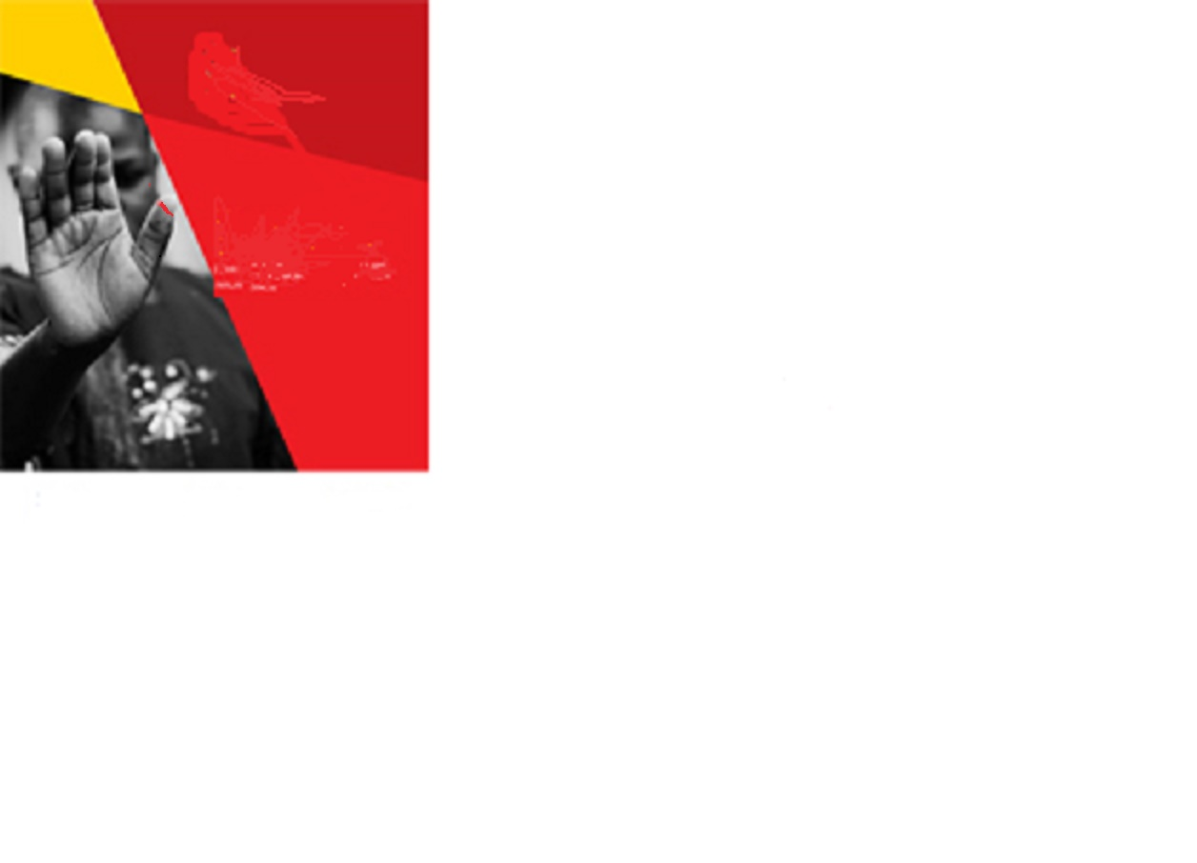
7. Lamulo logawa ndi kuteteza chuma chamasiye (Deceased Estates (Wills, Inheritance and Protection) Act.
(a) Lamulo limeneli linakhazikitsidwa ndi zolinga izi:
(i) kupereka ndondomeko ya m’mene munthu angafotokozera momwe chuma chake chizagawidwire akadzamawalira (kupanga Will);
(ii) Kupereka ndondomeko yakagawidwe kachuma cha malemu amene anamwalira osapeleka ndondomeko ya momwe chuma chake chizagawidwire atamawalira.
(iii) Kupereka ndondomeko ya m’mene chuma chamasiye chingatetezedwere;
(iv) Kupereka ndondomeko yazilango zoperekedwa kwa anthu osokoneza, kuba, kapena kowonga chuma chamasiye.
(v) kufotokozera za maphunziro odziwitsa anthu zamomwe chuma chamasiye chiyenera kugawidwira;
(vi) Kufotokoza mwatsatanetsatane za mphamvu za mabwalo amilandu pokhudzana ndi chuma chamasiye.
(b) Lamuloli linakhazikitsidwa pofuna kuthana ndi makhalidwe olanda kapena kusokoneza chuma chamasiye zimene zimapangitsa kuti otsala, makamaka amayi ndi ana, kunzunzika. Lamuloli limawonetsetsa kuti chuma chamasiye chigawidwe mwabata komanso mwandondomeko.
(c ) Lamulo limeneli limakhudza zakatundu wamalemu amene wamwalira akukhala mokhazikika mdziko lino, komanso malemu amene wamwalira kunja kwadziko la Malawi koma ali ndi chuma kapena katundu mdziko lino.
(d) Lamulo limeneli silikhudzana ndi kagawidwe kandalama zamalemu zinemene amansonkha mu thumba lovemerezadwa ndiboma zimene cholinga chake ndi kuzagwiritsa ntchito pamene munthu wapuma pa ntchito kapena pa bizinesi (mchizungu amati penshoni). Mwini osonkha ndalamazi amayenera kulembelatu mayina aanthu amene adzagawiridwe ndalama iye akadzamawlira.
(e ) Lamuloli ndilokhalo limene limapereka ndondomeka yogawira chuma chamasiye. Lamuloli silingagwire ntchito pokhapokha ngati palinso lamulo lina limene cholinga chake ndi kugawa chuma chotchulidwa mwapadera kuti chidzagawika ndi lamulo linalo.
Izi zikutanthauza kuti chuma chamasiye sichingagawidwe mwa mwambo wa mtundu wa kwa malemu chifukwa mwambo silamulo ladziko.

7.1 kulemberatu ndondomeko ya m’mene chuma chizagawidwire mwini chumayo akadzamawalira (kupanga Will).
Munthu aliyense woposa zaka zakubadawa zosachepera 18, komanso amene bongo wake ukugwira bwino ntchito anapatsidwa mphamvu ndi lamulo loti akhoza kulemberatu ndondomeko ya momwe chuma chake chidzagawidwire akadzamwalira. Munthuyu akamwalira chuma chake chimayenera kugawidwa motsatila izo adalemba asadamwalire.
Ngakhale lamulo silimalola munthu amene zaka zake zakubadwa ndi zosaposa18 kulembelatu kagawidwe ka chuma chake, pali mwayi oti munthu oteleyu akhoza kulemberatu kagawidwe ka chuma ngati wakwaniritsa mfundo izi:
(i) munthuyo ndi okwatila kapena okwatiwa motsata malamulo; kapena
(ii) munthuyo ndi mutu wa banja ndipo zake zake zakubadwa ndizosachepera 14 ; kapena
(iii) munthuyo ali ndi katundu wakewake mogwirizana ndi malamulo adziko.
7.2 Kodi Will imapangidwa motani?
7.2.1 Lamulo limafotokoza kuti Will imayenera kukhala motsata mfundo izi
(a) Ikhale yolembedwa ndipo mwini katunduyo ayenera kulemba motsimikikza kuti walemba ndi iye mwini (kapena kuti kusayinira). Mwini katunduyo ayenera kusaiyinira pa maso pa mboni ziwiri.
Mboni ziwiri zimenezi ziyenera kukhala ndi zaka zakubadwa zosachepera 18 komanso zikhale zoti bongo wawo akugwira ntchito bwinobwino.
(b) Mboni ziwirizi ziyenera kusayinira limodzi pa maso pa mwini katunduyo.
7.2.2 Munthu amene akukhala kunja kwadziko lino akhoza kulemba Will yofotokoza kagawidwe ka chuma chimene ali nacho m’dziko lino.
7.2.3 Asilikali amene apita kukamenya nkhondo kapena kukasungitsa bata ali ndi mwayi olemba Will yopanda mboni ziwiri. Komanso mboni iliyonse ikhoza kusayinira payokha. Izi zili choncho pozindikira kuti msilikali akakhala ku nkhondo kapena kosungitsa bata sangepeze mpata olemba Will mwandomeko yotsata zonse zimene lamulo limanena.

7.3 Mboni zosayinira Will
7.3.1 Chofunika kudziwa ndi chakuti mboni zosayinira Will siziloledwa kugawilidwa chuma kapena katundu wa mu Will imene iwo osayinira ngati mboni. Kuwonjezera apo, mkazi kapena mwamuna wa mboni ya Will saloledwa kulandira katundu ndi chuma cha mu Will mwini Will akadzamawalira. Mwachitsanzo, mkazi amene wasayinira ngati mboni pa Will ya Mwamuna wake, sakuloledwa kulandira chuma cha mwamuna wakeyo akadzamwalira angakhale kuti Will inanena kuti mkaziyo adzalandira nawo katundu kapena chuma. Chimodzimodzi mwana amene wasayinira ngati mboni pa Will ya kholo lake saloledwa kulandira katundu kapena chuma chogawilidwa mu Will ya kholo lakelo ngakhale Will itanenetsa kuti mwanayo akuyenera kulandira chumacho kapena katunduyo.
Chiletso chimenechi chinayikidwa pofuna kuwonetsetsa kuti mboni zisawopseze kapena kukakamiza mwini chuma kuti aziganizire podzagawa chuma ndi ndalama mu Will. Chiletsochi chimatetezanso kuti mboni zisakakamize olemba Will kuti azigawire mbonizo gawo lalikulu koposa anthu ena pamagawidwe achuma mwini chumayo akadzamwalira. Kotero ndikofunika kuti mboni za Will zisakhale anthu amene adzagawilidwe chuma akadzamwalira mwini chumayo.

7.3.2 Ngakhale izi zili choncho, mkazi kapena mwamuna wa malemu, kapena mwana wa malemu amene anasayinira ngati mboni ya Will ya Malemu akhoza kuloledwa kulandira chuma chamasiye akakadandaula kukubwalo lamilandu popereka mfundu izi:
(i) Ngati pasonyezedwa kuti panalibe mboni ina iliyonse imene ikanatha kusayinira Will ya malemu kupatulako mkazi, mwamuna kapena mwana wa malemuyo;
(ii) Ndalama kapena chuma chimene anagawilidwa mu Will ndi chomverera kapena ndi chuma choti akanakhala kuti malemu sanalembe Will chumacho chikanagawidwabe kwa mbonizo;
(iii) Palibe umboni owonetsa kuti panali zachinyengo zili zonse pakalembedwe ka Will komanso palibe umboni osonyeza kuti malemu anawumilizidwa pogayila chuma kmkazi, mwamuna kapena mwana wake mu Will.
Ngati bwalo lamilandu lakhutitsidwa ndi mfundozi, limavomereza kuti mkazi, mwamuna kapena mwana wa malemu alandire chuma chogawiridwa mu Will ngakhale anali mboni ya Will.
7.5 Kodi Will ikhoza kusingidwa kuti?
Munthu akhoza kusungitsa Will yake kumalo kapena anthu awa:
(a) Ku office kwa District Commissioner, ku office kwa Registrar General kapena ku bwalo lamilandu;
(b) Munthu wina aliyense odalilika;
(c) Nyumba zosungilako ndalama, kuntchito kwa anthu oyimila anthu pa milandu, komanso kumene munthu amagwira ntchito.
7.6 Kuwononga kapena kusintha Will
7.6.1 Munthu aliyense wamoyo ali ndi mphamvu yowononga, kufafaniza kapenanso kusintha Will yake. Munthu akhoza kulemba Will ina yosiyana ndi imene analemba poyamba.
7.6.2 Ngati munthu wamwalira atasiya ma Will awiri kapena angapo, Will imene inalembadwa potsiriza ndi imene imatengedwa kuti nde yoyenera kugwilitsidwa pogawa chuma chamasiye.
7.6.3 Munthu amene wafafaniza ena mwamalemba amu Will yake ayeneranso kusayinila za kufafanizako komanso mboni ziwiri ziyeneranso kusayinila limodzi pa maso pa mwini Will. Izi zimathandiza kupewa anthu ena kufufuta malemba a mu Will mwini wake atamwalira ndi cholinga chofuna kuti anthu ena asalandire nawo katundu wogawidwa ndi Will.

7.7 Zotsatira pa ukwati kapena kutha kwa banja
Lamulo limafotokoza zotsatira pamene munthu wakwatira kapena kukwatiwa atalemba kale Will, komanso zotsatira ngati munthu wathetsa banja atalemba kale Will.
(a) Munthu amene wakwatira kapena kukwatiwa atalemba kale Will, Will yakeyo imakhala yopanda ntchito ndipo iye akamwalira singagwilitsidwe ntchito pogawa chuma chamasiye. Koma ngati Will inamugawira katundu munthu amene wakwatirana naye, Will yotero imagwirabe ntchito ngakhale inapangidwa munthoyo asanakwatirane naye.
(b) Munthu amene analemba Will ali ndi mkazi m’modzi kenako mkutenga mkazi wina wachiwiri, Will imene analembayo imasanduka yopanda ntchito ndipo munthuyo ayenera kulembanso Will ina. Akatenganso mkazi wachitato, zotsatira zake ndi zoti ma Will onse am’mbuyo amakhala opanda ntchito.Izi zili choncho pofuna kuwonetsetsa kuti mkazi wakwatira kumene azakhale ndi mwawi olandira chuma cha masiye mwamuna akadzamwalira.
(c) Ngati banja latha munthu atalemba kale Will, katundu ndi chuma chogawidwa mu Will kwa osudzulidwayo sichingagawidwe kwa osudzulidwayo pamene mwini chumacho wamwalira. Mwachitsanzo, ngati mwamuna walemba mu Will kuti mkazi wake adzalandira galimoto mwamunayo akamwalira kenako banja ndi kutha, mkaziyo sangaloledwe kutenga galimotoyo mwamuna atamwalira.
(d) Ngati osudzulidwa anasankhidwa mu Will kuti adzatenga mbali pogawa kapena kuyendetsa chuma cha malemu, osudzulidwayo saloledwa kugawa kapena kuyendetsa chumacho. Udindo wake umathera pamene banja lathera.
(e) Chofunika kudziwa ndi chakuti munthu akhoza kulemberatu mu Will yake kuti kutha kwabanja kusadzapangitse osudzulidwayo kumanidwa Chuma chamasiye. Ngati zalembedwa motero osudzulidwa uja akhoza kulandira katundu wa mu Will pamene mwini chuma wamwalira.
7.7.1 Kuteteza mwamuna kapena mkazi otsala pabanja
(a) Lamulo logawa chuma chamasiye limateteza mwamuna komanso mkazi wa pabanja pakagawidwe ka chuma cha masiye. Malamulo adziko lino amavomereza mabanja amitundu itatu motere:
- Banja lomangitsa ku ofesi ya District Commissioner;
- Banja lomangitsa ku mipingo yosiyanasiyana, komanso yomangitsa kwa ankhoswe motsata miyambo yovemerezeka ya maukwati;
- Pamene mkazi ndi mwamuna akhalila limodzi ngati banja kwa ka nthawi posatengera kuti banjalo linamangitsidwa pa mwambo wamtundu wina uliwonse.
(b ) Popeza pazikhalidwe zina mdziko lino abambo amavomerezedwa kukwatira mitala, akazi apamitalapo ali ndi ufulu olandila nawo chuma chamasiye cha mwamuna wawo.
(c ) Mkazi kapena mwamuna wa pabanja lamitundu tatchula ija ali ndi mwayi olandira nawo chuma cha masiye cha pabanjalo motsatana ndi malamulo.
7.8 Mkazi, mwamuna, ndi ana osagawilidwa katundu mu Will ya Malemu
7.8.1 Tawona kale kuti Will imafotokoza za anthu amene adzagawiridwe chuma chamasiye mwini chumacho akamwalira. Kotero munthu ali ndi ufulu osagawira katundu wina aliyense kwa ana ake, amuna ake kapena akazi ake. Izi ndi zololedwa ndi Malamulo. Komabe pali nthawi zina pamene mwini chuma akhoza kuyiwala mwangozi kuwagawila chuma ana ake, akazi ake kapena amuna ake mu Will. Pofuna kuwonetsetsa kuti anthu oyiwalidwa mwangoziwa alandire nawo chuma chamasiye, lamumolo limalola athuwa kuti akadandaule ku bwalo la milandu ndi cholinga choti apeze mwayi olandira nawo chuma chamasiye.
7.8.2 Bwalo lamilandu lisanalamule kuti anthu oyiwalidwawa mu Will alandire nawo chuma chamasiye, limayamba lalingalila mfundo izi:
(a) Limawona kuchuluka kwa chuma chamasiye;
(b) Kapezedwe ka chuma ka mkazi, mwamuna kapena ana oyiwalidwa mu will. Bwalo limawona ngati anthuwa aliodziyimila paokha pa za umoyo wawo watsikunditsiku;
(c) Makhalidwe pakati pa mkazi, mwamuna kapena ana oyiwalidwa mu Will ndi mwini chuma pamene anali wa moyo;
(d) Kapezedwe kachuma ka anthu ena amene ogawilidwa chuma mu Will imene yawiwala mkazi, mwamuna kapena ana a mwini chuma.

8. Chuma chamalemu amene sanasiye ndondomeko yakagawidwe ka chuma chake
Pamene munthu wamwalira osalemba will, lamulo linakhazikitsa ndondomeko yamomwe chuma chake chingagawidwile. Magulu aanthu titchulewa ndi amene amayenera kulandira chuma chosagawidwa ndi Will.
(a) Mwamuna kapena mkazi wa malemu;
(b) ana amalemu kuphatikizapo ana owapeza;
(c) Makolo amalemu;
(d) munthu wazaka zakubadwa zosadutsa 18 amene maphunziro ake amalipilidwa ndi malemu komanso woti sangathe kudzithandiza yekha
(e) Achibale ena ovomerezedwa ndi lamulo.

Kagawidwe ka katundu opanda Will
Chuma chamasiye chimene sichinanagawidwe ndi Will chimagawidwa potsatira mfundo izi:
- Mkazi, mwamuna, ana, ndi makolo amalemu ayenera kuwonetsetsedwa kuti alandira katundu ndi chuma chamasiye moyambirira ndi cholinga choti asakhale mu umphawi poyelekeza ndi achibale ena amane akuyenere kulandira nawo chuma chamasiyecho.

- Mkazi kapena mwamuna wamalemu ayenera kutenga katundu yense wa m’nyumba imene iye amakhala;

- Katundu wina otsala ayenera kugawidwa pakati pa mkazi kapena mwamuna wa malemu ndi ana a malemu mu mlingo yofanana;

- Mkazi kapena mwamuna wa malemu ndi ana amalemu akuyenera kugawilidwa chuma cha masiye chopanda Will motsata mfundo izi:

- Mafuno akagawidwe ka chuma amene malemu anafotokoza pa maso pa mboni zodalilika;

- Mathandizo a sukulu kapena katundu osiyanasiyana amene mkazi, mwamuna ndi ana malemu amalandira kwa malemu ali moyo;

- Mathandizo amene mkazi, mwamuna, ndi ana amapeleka ku bizinezi kapena kukatundu wa malemu ali moyo. Lamulo limanena kuti mkazi kapena mwamuna wa malemu akutengedwa kuti amathandizira ku bizinesi kapena katundu wa malemu ali moyo. Izi zikhoza kutsutsidwa ngati pa li umboni otsutsawo.

- Ngati malemu anasiya ana angapo, mwana wa mng’ono pa ana onse ayenera kugawilidwa gawo lalikulu la chuma chamasiye.Mwana wamng’ono akhoza kulandira chuma chochepelako pokhapokha ngati ana akuluakulu okuyenera kulandira mathandizo ochulukilapo malingana ndi zofunika pa moyo wawo.

- Ngati malemu sanasiye ana, mkazi kapena mwamuna, katundu wamalemu amagawiridwa mu mlingo yofanana pakati pa makolo ake amalemu ndi munthu osakwana zaka 18 zakubadwa amene amathandizidwa pa maphunziro ndi malemu.

8.2 Kagawidwe ka chuma pamene malemu wasiya akazi angapo ba panja
(a) Ngati malemu opanda Will wasiya akazi angapo koma okhala kumadera osiyanasiyana, mkazi aliyense ndi ana ake oberekedwa ndi malemu ayenera kugawana katundu yense wa m’nyumba imene iye ikukhala ndi ana ake.
(b) Mkazi ndi ana amalemu okhala mdera lina sakuyenera kulandira nawo katundu amene ali m’nyumba ya mkazi wina wamalemuyo ndi ana ake amene akukhala kudera lina.
(c ) Kagawidwe ka nyumba ndi malo amene ali ndi mapepala aboma, ndalama zimene malemu wasiya ku banki, kuntchito , kuboma kapena kubwalo lamilandu, komanso ngati katundu yense amene malemu anasiya ndi osaposa K1,000,000 kali ndi ndondomeko yake yake.Ndondomekoyi tiyiwona kutsogoloku.
(d ) Ngati malemu wasiya akazi angapo koma onse okhala m’nyumba imodzi, akaziwa ndi ana awo oberekedwa ndi malemu akuyenera kulandira chuma chamalemu mu mlingo yofanana.

8.3 Kodi mkazi kapena mwamuna otsala angakwatiwenso atalandira chuma cha masiye?
(a) Mkazi kapena mwamuna amene walandira chuma cha masiye popanda Will akhoza kukwatiwanso kapena kukwatilanso popanda kulandidwa chuma chimene analandira kwa malemu. Izi zikutanthauza kuti achibale amalemu sangalande chuma chimene chinaperekedwe kmkazi kapena mwamuna wamalemu chifukwa choti mkaziyo kapena mwamunayo wapeza banja lina. Ngakhale izi zili chonco, mkazi kapena mwamuna wamalemu amene wapeza banja akuyenera kulandidwa katundu amene ali pa malo akumudzi amtundu wa malemu ndipo katunduyu amaperekedwa kwa ana amalemu.

8.4 Kodi malemu ngati sanasiye mkazi, mwamuna, ana kapena makolo, katundu amagawidwa motani?
(a) Poyambilila, katundu akuyenera kugawidwa mu mlingo wofanana kwa adzukulu a malemu
(b) Ngati palibe adzukulu katundu akuyenera kugawidwa kwa achimwene ndi achemwali abele limodzi ndimalemu mu mlingo wofanana;
(c) Ngati palibe achemwali ndi achimwene, katundu akuyenera kugawidwa kwa achimenwe ndi achemwali amalemu ngakhale asali abele limodzi;
(d) Ngati palibe achimwene ndi achemwali amtundu uliwonse, katundu akuyenera kugawilidwa kwa agogo amalemu mu mlingo wofanana;
(e) Ngati palibe agogo, katundu akuyenera kugawidwa kwa atsibweni, azakhali ndi aphwawo a malemu mu mlingo wofanana;
(f) Ngati palibe atsibweni, azakhali ndi aphwawo a malemu, katundu akuyenera kugawilidwa kwa achibale ena amalemu mu mlingo wofanana;
(g) Ngati malemu alibe wachibale wina aliyense, katundu amatengedwa ndi boma.

8.5 Mphamvu za bwalo la milandu lalikulu(High Court) pa nkhani za chuma chamasiye
Bwalo la milandu lalikulu lili ndi mphamvu izi pa nkhani zokhudzana ndi chuma chamasiye
(a ) Kugamula ngati malemu anasiya Will pomwalira. Komanso kugamula ngati Will imene analemba malemu ndi yovomerezeka ndi malamulo;
(b) Kugamula ngati katundu anali wake wa malemu pa nthawi imene ankamwalira;
(c ) Kugamula ngati munthu akuyenera kulandira nawo chuma chamasiye;
(d ) Kugamula ndondomeko ya m’mene chuma chamasiye chingagawidwire;
(e ) Kulamula kuti katundu wamalemu agawidwe kapena agulitisidwe kuti abweze ngongole zimene malemu anasiya;
(f ) Kusankha munthu oyang’anira mwana wamasiye amene wasiyilidwa chuma ndi malemu

8.6 Mphamvu za bwalo lamilandu laling’ono (Magistrate Court) pankhani zokhudzana ndi chuma chamasiye.
Bwalo lamilandu laling’gono lili ndi mphamvu zofanana ndi za bwalo lalikulu lamilandu.Kusiyana kwake ndi kwakuti bwalo la milandu laling’ono lili ndi mphamvu pa nkhani za chuma chamasiye chosaposera K1,000,000.

8.7 Kuteteza chuma chamasiye kuti chisawonongeke
Ngati malemu wasiya katundu oti akhoza kuwonongeka mwachangu kapena pali ma umboni osonyeza kuti katundu wamasiye akhoza kugwilitsidwa ntchito mosemphana ndi malamulo akagawidwe a chuma chamasiye, bwalo lamilandu likhoza kulamula anthu awa kuti ayang’anire chumacho poyembekezera kuti chigawidwe:
(a) Munthu amene ali ndi gawo mu chuma chamasiyecho
(b) Munthu amene amasunga kapena kuyang’’anira chumacho panthawi imene malemu amamwalira;
(c) Mlangizi wa za malamulo wa malemu

8.8 Zufunika kuchita kuti anthu alandire katundu wogawidwa ndi will
Pamene munthu amene analemba Will wamwalira, pamafunika kutsata ndondomeko zingapo kuti otchulidwa mu Will alandire chuma chamasiye. Ndondomeko ziri motere:
- Will yamalemu iyenera kutengeredwa ku bwalo lamilandu kuti likatsimikize kut Will ndi yovemerezeka ndi malamulo. Amene angatengere Will ku bwalo lamilandu ndi anthu amene malemu anasankha mu Will kuti ndi amene adzagawe kapena kuyendetsa chuma chamasiye.

- Bwalo lamilandu likatsimikiza kuti Will ndi yovomerezeka ndi malamulo, anthu amene Will inasankha kuti agawe kapena kuyendetsa chuma cha masiye amapatsidwa mphamvu yogawa kapena kuyendetsa chuma motsatana ndi zimene zinalembedwa mu Will.

- Ngati Will sinasankhe anthu ogawa kapena kuyendetsa chuma chamasiye, kapena pemene anthu osankhidwa kugawa ndi kuyendetsa chuma akana kutenge udindowo, kapena amwalira, kapena achita misala, kapena sakupezeka, pamayenera kuchitaka zinthu izi:

Amene agawilidwa katundu mu Will, kapena anthu amene malemu anali nawo ngongole, kapena ofesi yoyang’anira kagawidwe ka chuma cha masiye (Administrator General) akuyenera kupita kubwalo la milandu kuti apatsidwe mphamvu zogawa kapena kuyendetsa chuma chamasiye mutsata zimene Will yanena. Munthu wina aliyense alibe mphamvu yogawa kapena kuyendetsa chuma cha masiye pokhapokha ngati bwalo lamilandu lamupatsa undindo umenewu.

- Udindo wogawa kapena kuyang’anira chuma chamasiye umayenera kupelekedwa kwa anthu osachepera awiri komanso osaposera anayi. Banki kapena bungwe lovomerezeka ndi boma, komanso office ya Adminsitrator General ndi ololedwa kupatsidwa mphamvu zogawa ndi kuyanira chuma chamasiye mwa iwo okha.

- Munthu amene anagawilidwa chuma mu Will ali ndi mphamvu zotsutsa pazifukwa zomveka bwino ku bwalo la milandu pa kasankhidwe ka anthu oyang’anira kapena kugawa chuma cha masiye.

8.9. Kodi munthu akamwalira osasiya Will choyenera kuchita ndi chani kuti katundu wamasiye agawidwe?
(a) Munthu akamwalira opanda will, pameyenera kutsata ndondomeko zingapo kuti otsala alandire katundu wa masiye. Lamulo limanena kuti anthu amene ali ovomerezeka ndi lamulo kuti alandire nawo katundu wa malemu amene anamwalaira opanda Will, ali ndi mphamvu zopita kubwalo lamilandu kuti akapatsidwe chilolezo chogawila kapena kuyang’anira chuma chamasiye.
(b) Chofunka kudziwa ndi chakuti, anthu oyenera kulandira chuma chamasiye popanda Will anayikidwa mu mn’dandandawa momwe angagawilidwile chumacho. Mn’dandaumenewu umagwilitsidwanso ntchito pakatengedwe ka chilolezo kubwalo lamilandu chopereka mphamvu zogawila kapena kuyendetsera chuma chamasiye.Mwachitsanzo abambo amalemusangaloledwe kukatenga chilolezo ku bwalo lamilandu chogawila kapena kuyendetsera chuma chamasiye pamene mkazi kapena mwamuna wa malemu alipo.
(c ) Chilolezo chogawila kapena kuyendetsera chuma cha masiye popanda Will chimapelekedwa kwa anthu osachepera awiri komanso osapitilila anayi. Izi zikutanthauza kuti mwamuna, mkazi kapena mwana wa malemu sangapatsidwe chilolezochi payekha. Mwachitsanzo, mkazi kapena mwamuna wa malemu akuyenera kukapempha kubwalo lamilandu chilolezo choyendetsera kapena kugawila chuma cha masiye pamodzi ndi mwana wa malemu osachepera zaka 18.
(d ) Anthu oyenera kulandila chuma cha masiye popanda Will ali ndi mphamvu yokapempha kubwalo la milandu chilolezo choyang’anira kapena kugawa mbali imodzi ya chuma cha masiye. Mwachitsanzo ndalama zome malemu anasiya ku banki ndi cholinga chothandizira mwana wa pa sukulu kapena kubweza ngongole za malemu
(e ) Anthu amene apatsidwa chilolezo chogawa ndi kuyang’anira katundu wa masiye popanda Will akuyenera kugawa kapena kuyang’anira katunduyo motsata ndondomeko ya malamula akagawidwe ka chuma cha masiye..

8.10. Kuchotsa pa udindo anthu ogawa ndi kuyanganira chuma cha masiye
Bwalo lamilandu lili ndi mphamvu zochotsa pa udindo anthu osankhidwa kapena ololezedwa kugawa ndi kuyang’anira chuma cha masiye pa zifukwa izi:
- Ngati kasankhidwe kawo kapena katengedwe kachilolezo kubwalo lamilandu kanachitika mwachinyengo kepana mwabodza.

- Ngati udindo wawo siukusowekera kukhalapo;

- Ngati audindowa alephera kufotokoza momwe ayendetsera chuma cha masiye, kapena ngati apeleka umboni wabodza pa momwe ayendetsera chuma cha masiye.
Bwalo la milandu lili ndi mphamvu zosankha audindo ena kuti adziyang’anira kapena kugawa chuma chamasiye kulowa m’malo mwa a udindo ochotsedwa kapena kuyimitsidwa.

8.11. Kagawidwe ka katundu wamasiye wosaposera K1,000,000
(a) Bwalo la milandu laling’ono (Magistrates Court) lili ndi mphamvu pankhani zokhudzana ndi chuma kapena katundu wamalemu osaposera K1,000,000;
(b) Anaamalemu amene ali oposera zaka 18 zakubadwa, mkazi kapena mwamuna wamalemu ndi achibale amalemu amene ali ovomerezedwa ndi lamulo kulandira chuma chamasiye popanda will, amaloledwa kuti agwilizeni kagawidwe ka chuma cha masiye. Izi zimaloledwa pokhapokha ngati katundu wamasiye ndi osaposera K1,000,000. Katunduyo ameyenera kukhalonso oti sanagawidwe ndi Will
(c ) Mgwirizano wa paubalewu wakagawidwe ka katundu wa malemu umayenera kulembedwa ndikukapelekedwa ku ofesi ya District Commissioner mwaumboni. Mgwirizanowu sukuyenera kukhudza ndalama zimene malemu anasiya ku banki, kuboma kapena ku bwalo lamilandu, komanso sukuyenera kukhudzana ndi malo amasiye amene ali ndi makalata akuboma.

8.12 Kagawidwe ka malo amene ali ndi makalata aboma
(a) Ngati Malemu wasiya malo amene ali ndi makalata aboma, malowo angagawidwe kapena kugulitsidwa ndi anthu okhawo osankhidwa mu Will kapena anthu ovomerezeka ndi bwalo la milandu.Munthu amene sanasankhidwe ndi Will kapena osavomerezaka ndi bwalo lamilandu sangagawe kapena kugulitsa malo a mtundu umenewu.
(b) Izi zikutanthauza kuti ngati malemu wasiya malo kapena nyumba imene ili ndi makalata aboma, achibale, mkazi, mwamuna kapena ana amalemu akuyenera kukatenga chilolezo kubwalo la milandu kuti aziyang’anira, kugulitsa kapena kugawa malo amenewa.

8.13. Kagawidwe ka ndalema zamasiye zosiyidwa ku banki, kuboma, kapena kubwalo lamilandu.
(a) Achibale amalemu kapena anthu osankhidwa mu Will amene ali ndi umboni osonyeza kuti malemu anasiya ndalama akuyenera kukafotokoza ku ofesi ya District Comissioner wa m’boma la kumudzi kwawo kwa malemu kapena m’boma limene malemu amakhala.
(b) Ofesi ya District Commissioner ikalandira umboniwu ifufuze kuti itsimikize kuchuluka kwa ndalama zimene malemu wasiya;
(c) Ngati ndalama zinagawidwa ndi Will, ofesi ya District Commissioner ikuyenera kuwunikira achibale kuti apite kubwalo la milandu kuti akatenge chilolezo chotengera ndi kugawila ndalama za malemu;
(d) Ngati ndalama sizinagawidwe ndi Will ofesiDistrict Commissioner ikuyenera kutsata ndondomeko izi:
(i) Ofesi District Commissioner ikuyenera kupititsa nkhani ku bwalo lamilandu kuti livomereze ndi kutsimikiza mayina aanthu amene akuyenera kulandira ndalama za malemu komanso ndondomeko yakagawidwe ka ndalamazo;
(ii) Bwalo lamilandu likavomereza ndi kutsimikiza mayina aanthu amene akuyenera kulandira ndalama za malemu, limatumiza mayinawo ndi ndondomeka yakagawidwe kandalamazo ku ofesi ya District Commissioner;
(iii ) Ofesi ya District Commissioner ikalandira mayina kuchokera kubwalo la milanduimapempha amene akusungu ndalama za malemu kuti apeleke ndalamazo ku ofesi ya District Commissioner. Ndalama zimayenera kuperekedwa kwa District Commissioner pasanathe miyezi itatu;
(iv ) Ofesi ya District Commissioner ikalandira ndalama iyenera kugawira ndalamazo kwa anthu amene bwalo la milandu linavomereza kuti alandire ndalama za malemu;
(v) Ngati mwana ochepera zaka 18 zakubadwa wagawilidwa ndalama, ndalama zake zikuyenera kusungidwa mu buku la ku banki loyang’aniridwa ndi ofesi ya District Commissioner. Ndalamazi zimaperekedwa pokhapokha ngati mwanayo akufuna kuzigwiritsa ntchito pa moyo wake.
(e) Ngati ndalama zimene wasiya malemu ndi zoposa K1,000,000, ndikoyenera kuti ofesi ya Administrator General itenge udindo ogawa ndalamazo. Ofesi ya Administrator General imapezeka ku Lilongwe, Blantyre ndi ku Mzuzu.

8.14. Udindo wa anthu ogawa ndi kuyang’anira chuma cha masiye.

(a) Akuyenera kulipila ngongole za malemu, msonkho otsiliza komanso kulipila zokhudzana ndi maliro a malemu.;
(b) Kugawa katundu motsata zimene Will yanena;
(c) kugawa ndi kuyang’anira chuma cha masiye chopanda Will motsata ndondomeko ya malamulo.

8.14.1 Ndalama zonse zogwilitsidwa ntchito poyang’anira kapena kugawa chuma cha masiye ziyenera kuchokera ku chuma cha masiyecho. Adindo ogawa kapena kuyang’anira chuma cha masiye sakuyenera kugwiritsa ntchito ndalama za m’nthumba mwawo poyang’anira kapena kugawa chuma cha masiye
8.14.2 Anthu osankhidwa kapena kuvomerezedwa kuyang’anira kapena kugawa chuma cha masiye saloledwa kulandila nawo katundu kapena chuma chamasiye, kapena kupindula ndi chuma cha masiye. Anthuwa angathe kulandira nawo chuma kapena katundu wamasiye pokhapokha izi zitakwaniritsidwa:
(i) Ngati Will inawagawilako katundu kapena chuma cha masiye;
(ii) Ngati anthuwa ndi ovomerezeka ndi lamulo kuti akhoza kulandira nawo chuma cha masiye popanda Will.Mwachitsanzo mkazi, mwamuna, kapena ana amalemu.

8.15. Milandu yokhudzana ndi chuma cha masiye
Pofuna Kuthana ndi kuba, kuwononga kapena kusakaza chuma cha masiye, lamulo linakhazikitsa milandu ndi zilango kwa onse amene angaphwanye ma lamulo akagawidwe ka chuma cha masiye.
Munthu wina aliyense amene angalande, kusokoneza, kapena kuba chuma chamasiye akuyenera kulandira chilango chokakhala ku ndende kwa zaka khumi. Kuphatiza apo, munthuyo akuyenera kulipila chindapusa chokwana K1,000,000. Zilango zimenezi zimapelekedwanso kwa adindo oyang’anira komanso kugawa chuma chamasiye akaphwanya malamulo akagawidwe ka chuma cha masiye.
Bwalo la milandu lili ndi mphamvu zolamula munthu amene waba, kusokoneza kapena kulanda chuma cha masiye kuti abweze chumacho kwa olandidwa. Bwalo la milandu lilinso ndi mphamvu zolamula kuti katundu wa munthu amene waba, kulanda kapena kosokoneza chuma chamasiye alandidwe chuma chake ndi cholinga chobwezeletsa chuma chamasiyecho.

8.16. Malipilo apantchito a malemu
Ngati malemu anali pa ntchito yolembedwa ndipo amayenera kulandira malipiro ake aku ntchito asanamwalire, malipilowo akuyenera kupelekedwa kmkazi kapena mwamuna wamalemu. Ngati Malemu sanasiye mkazi kapena mwamuna, malipilowo akuyenera kupelekedwa kwa munthu wamkulu amene amakhala ndi malemu.
Munthu amene walandila malipilo amenewa ndi ololedwa kugwilitsa ntchito ndalamazo pakhomo la malemu komanso pothandizira za mwambo wa maliro amalemu.

8.17. Okupha Malemu sakuyenera kulandira chuma chamasiye
Munthu amene wapha malemu sakuloledwa ndi lamulo kuti alandire nawo chuma chimene malemuwo asiya ngakhale atagawilidwa chuma mu Will.

(insert cover photo of the gender equality act)

9. Lamulo lothetsa kusalana mu maufulu pakati pa amayi ndi abambo (The Gender Equality Act)

9.1 Zolinga za lamulo la Gender Equality
- Kuletsa ndi kuthana ndi miyambo yachikhalidwe chamakolo, miyambo ya mipingo ndi zipembedzo komanso zikhalidwe zosiyanasiyana zimene zimaphwanya kapena kuponderaza maufulu amayi ndi abambo;

- Kuthana komanso kuletsa nkhanza zochitika pa nkhani za chisembwele ndi zogonana pakati pa amayi ndi abambo komanso ana achichepele

- Kulimbikitsa kuti amayi azitenga nawo gawo pa zinthu zochitika pa moyo wayo, mdera lawo komanso mdziko.

- Kulimbikitsa kuti amayi, atsikana ndi amuna azikhala ndi mwayi ofanana wa ma phunziro;

- Kuteteza ufulu wa anthu onse pokhudzana ndi uchembere wabwino.

9.2 Kuletsa kupondelezana pakati pa amayi ndi abambo
(a) Munthu aliyense sakuyenera kupondereza munthu wina chifukwa chakuti munthu winayo ndi mkazi kapena mwamuna.
(b) Munthu aliyense sakuyenera kuyika mfundo pa zinthu zosiyanasiyana:
(i) ndi cholinga choti anthu akazi ochepa, kapena amuna ochepa ndi amene athe kukwaniritsa mfundozo;
(ii) zimene zilibe zolinga zeni zeni zomveka;
(iii ) zimene zikuphwanya maufulu a chibadidwe aanthu.
(insert photo of boys and girls in class)
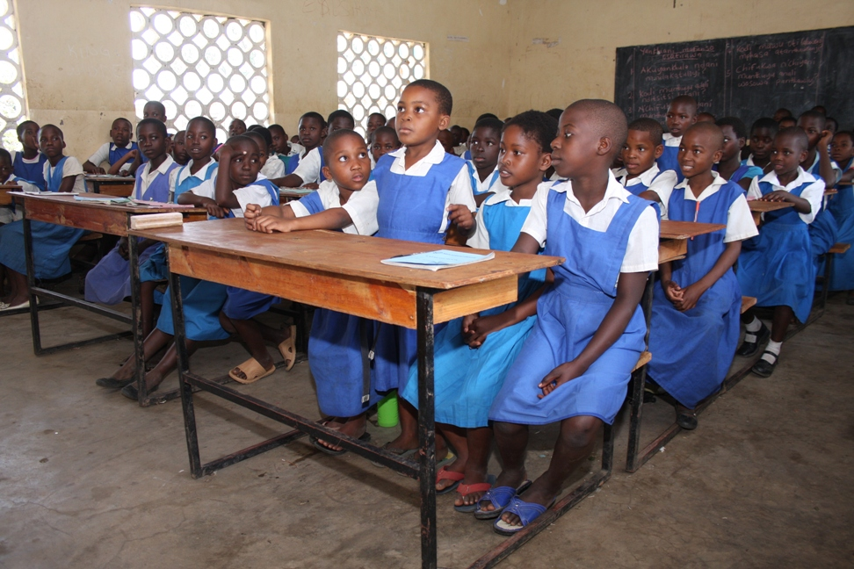
(c ) Munthu amene wayika mfundo tatchulazi akuyenera kuzengedwa mlandu umene chilango chake ndi kukhala mu ndende kwa zaka zisanu komanso kulipila chindapusa chandalama zokwana K1,000,000.

9.3 Kuletsa ndi Kuthana ndi makhalidwe oyipa
(a) Lamulo likuletsa makhalidwe ndi miyambo yoipa ya mitundu ina iliyonse imene:
- imachotsa ulemu wa akazi kapena amuna;
- ikhoza kuwononga umoyo wa akazi kapena amuna;
- ikuphwanya ufulu wa akazi kapena amuna
- ingavulaze thupi la mkazi kapena mwamuna
- Ingazunze maganizo a mkazi kapena mwamuna
(b) Munthu wina aliyense, mabungwe, mipingo akuletsedwa ndi lamulo kuti asachite kapena kupititsa patsogolo makhalidwe ndi miyambo yoletsedwayi.
(c ) Munthu amene wapezeka akuchita kapena kuvomereza miyambo yoletsedwayi adzayimbidwa mlandu umene chilango chake ndi kukhala ku ndende zaka zisanu komanso kulipira chindapusa cha ndalama zokwana K1,000,000.

9.4 Kuletsa nkhanza ndi chitonzo pa nkhani zachisembwerendi zogonana
(a) Munthu wina aliyense, mwamuna kapena mkazi, ndi oletsedwa kupanga nkhanza kapena kulankhula ndi kuchita za chitonzo pa zachisembwere ndi zogonana kapena pa nkhani zachiswembere ndi zogonana.
(b) Amene wachita nkhanza zogonana ndi zachisembwere, kulankhula kapena kuchita zachitonzo pa zogonana ndi zachisembwere adzayimbidwa mlandu. Chilango cha mlandu umenewu ndi kumangidwa kukakhala kundende komanso kulipila chindapusa chokwana K1,000,000

9.5 Udindo wa boma pothana ndi nkhanza ndi chitonzo pa nkhani zachisembewere ndi zogonana mu malo ogwira ntchito.
(a) Boma lili nid udindo oyika ndondomeko zowonetsetsa kuti anthu, kapena ma kampani olemba anthu ntchito akhazikitsa mfundo ndi ndondomeko zothana ndi nkhanza ndi chitonzo pa zogonana ndi zachisembwere pa malo antchito.

9.6 Udindo wa olemba anthu ntchito pothana ndi nkhanza ndi chitonzo pa zogonana ndi zachisembwere pa malo antchito.
Olemba anthu ntchito ali ndi udindo okhazikitsa ndondomeko yoletsa ndi Kuthana ndi nkhanza ndi chitonzo pa zachisembwere ndi zogonana pa malo antchito. Ndondomekozo ziyenera kukhala ndi mfundo zotere:
(a) Munthu wina aliyense amene wachitilidwa nkhanza kapena chitonzo pa malo antchito akuyenera kukhala ndi ufulu odandaula ku ntchitoko. Pakuyenera kukhala chitsimikizo kuti munthu amene wachita nkhanza kapena chitonzo pa zachisembwre pa malo antchito adzalangidwa moyenerera;
(c ) Munthu olembedwa ntchito, ofunsila ntchito aliyense komanso anthu ofuna chithandizo kuntchito akuyenera kupatsidwa ulemu wa umunthu;
(d ) Munthu olembedwa ntchito asazunzidwe chifukwa choti wadandaula pa za nkhanza kapena chitonzo pa zogonana ndi zachisembwele pa malo antchito .
Munthu amene wachitilidwa nkhanza kapena chitonzo pa zogonana ndi zachisembwele pa malo antchito ali ndi ufulu okadandaula ku bwalo la milandu kapena kupolisi.
(insert male and female nurses or engineers)
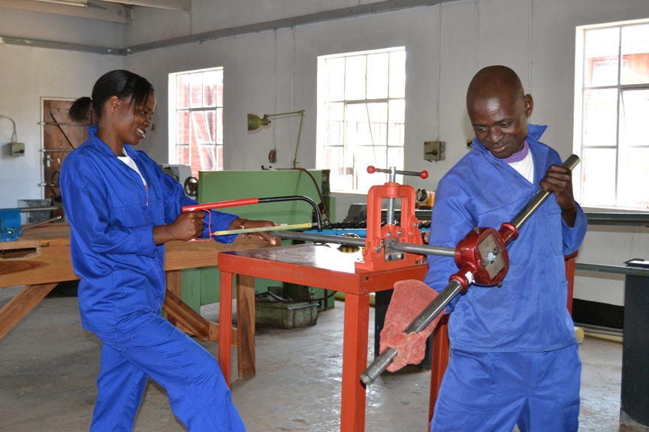

9.7 Udindo wa bungwe la Malawi Human Rights Commission
(a) Bungwe la Malawi Human Rights Commission lapatsidwa undindo owonetsetsa kuti lamulo la Gender equality likutsatidwa mdziko lino.
(b) Bungweli lapatsidwano mphamvu izi:
(i) Kusanthula ndondomeko ndi mfundo za boma, mabungwe aboma ndi ma kampani ena onse pofuna kuwonetsetsa kuti ufulu wa amayi ndi abambo ukutetezedwa ndi kulimbikitsidwa
(ii) Kulandira ndi kufufuza madandaulo okhudzuna ndi kuphwanyidwa kwa maufulu pakati pa amayi ndi abambo;
(iii) Kulangiza nduna yoowona za ana ndi maufulu apakati pa amayi ndi abambo pa nkhani zokudzana ndi maufulu apakati pa amayi ndi abambo;
(iv) Kuwunikira komanso kupereka uphungu ndi chithandizo pa nkhani zokhudzana ndi maufulu ndi udindo pakati pa mamayi ndi abamabo.

9.8 Kulembedwa ntchito ku Boma.
(a) Olemba ntchito ku boma kapena mabungwe amene ali aboma akuyenera kuwonetsetasa kuti pa anthu khumi aliwonse amene akulembedwa pa ntchito, anthu osachepela anayi mwa olembedwawo akhale amuna ndipo anthu osaposera asanu ndi m’modzi akhale akazi; kapena anthu osachepela anayi mwa olembedwawo akhale akazi ndipo anthu osaposera asanu ndi m’modzi akhale amuna.
Cholinga chalamulo limeneli ndikuwonetsetsa kuti amayi ndi abambo akhale ndi mwayi ofanana olembedwa ntchito ku boma kapena mabungwe aboma ngati ali ndi maphunziro oyenera pa ntchitoyo. Mwachitsanzo, ngati boma likufuna kulemba aphunzitsi okwana khumi, likuyenere kulemba aphunzitsi osachepera anayi amuna komanso aphunzitsi osaposera asanu ndi m’modzi akazi; kapena kulemba aphunzitsi osachepera anayi akazi komanso aphunzitsi osaposera asanu ndi m’modzi amuna. Lamulo limeneli silingagwilitsidwe ntchito ngati pali zifukwa izi:
.
(i ) ngati amuna kapena akazi amene akufuna kulembedwa ntchitoyo alibe maphunziro oyenera kapena ngati sanagwileko ntchito ngati imene akufunayo.
(ii ) ngati amuna kapena akazi sanayivomeleze ntchitoyo.
(iii ) ngati anthu amuna kapena akazi amene ali ndi maphunziro oyenera, kapena omwe anagwilako ntchitoyo, sanapezeke
(b ) Munthu amene ali ndi umboni osonyeza kuti anthu olemba ntchito ku boma kapena mabungwe aboma sakutsata lamuloli, ali ndi ufulu okandandaula ku bwalo la milandu. Ngati bwalo lamilandu lapeza kuti lamuloli laphwanyidwa, likhoza kulamula olemba ntchitowo akuti atsate lamulo.Ngati olemba ntchito samvera chigamulo chabwalo la milandu, bwalolo likuyenera kulamula olembe ntchitowo kuti adzilipila chindapusa cha K20,000 pa tsiku lilonse limene akunyozera chigamulo cha bwalo la milandu..

9.9 Chilungamo pakalembedwe ka anthu apa ntchito ku boma ndi mabungwe aboma.
(a) Munthu aliyense amane wayesedwa mayeso olembera anthu ntchito ku boma kapena ku bungwe la boma ali ndi ufulu otere:-
(i) Kuwuzidwa kudzera mkalata zifukwa zimene sanalembedwere ntchito;
(ii) Kuwona zolembedwa zoonetsa m’mene mayesowo anayendera. Izi zikuyenera kuperekedwa pasanathe mwezi.

9.10 Maphunziro
(a) Munthu aliyense (mwamuna kapena mkazi) ali ndi ufulu opanga maphunziro a sukulu ndi antchito osiyanasiyana mopanda tsankho.
(b) Boma lili ndi udindo woyika ndondomeko zowonetsetsa kuti ma sukulu osiyana siyana akupeleka:
(i) maphunziro ofanana kwa ophunzira a akazi ndi amuna;
(i) mayeso ofanana kwa ophunzira a akazi ndi amuna;
(iii) aphunzitsi a ukadawulo ofanana kwa ophunzira a akazi ndi amuna;
(iv) mabuku ndi zida zophunzitisila zofanana kwa ophunzira a akazi ndi amuna
(v ) nyumba zozithandizira za ulemu motengera ndi zofunika zapadera pakati pa ophunzira pa sukulu.
(c ) Boma lili ndi udindo owonetsetsa kuti pa anthu khumi aliwonse amene akusankhidwa kupita kumasukulu aboma azaukachenjede ndi za ukadaulo, anthu osachepela anayi akhale akazi ndipo anthu osaposera asanu ndi m’modzi akhale amuna; kapena anthu osachepala anayi akhale amuna ndipo anthu osaposera asanu ndi m’modzi akhale akazi.

9.11 Mwayi wachithandizo cha ndalama zolipilila sukulu
(insert a photo of PMCT or wife and husband breastfeeding)
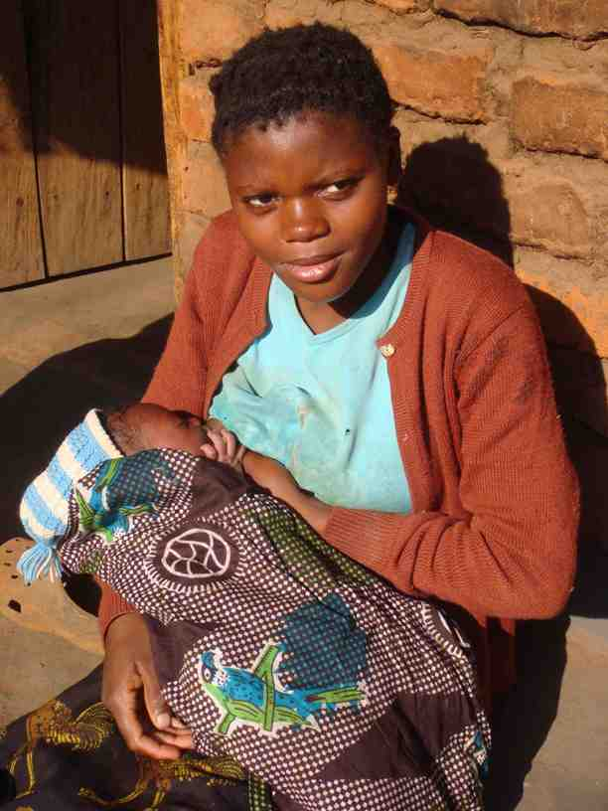
Munthu wina aliyense ali ndi ufulu opeza nawo mwayi opatsidwa chithandizo cha ndalama cholipilila sukulu kuchokera kuboma, maboma akunja, ndi mabungwe osiyanana siyana mosatengera kuti munthu ndi mkazi kapena wa mamuna.

9.12. Ufulu wa uchembele wabwino komanso kugonana kwabwino
(a) Munthu aliyense ali ndi ufulu wa uchembele wabwino komanso kugonana kwabwino umene ulinso ndi maufulu awa:
(i) ufulu opeza njira zakulela komanso zozitetezela kumatenda opatsirana pogonana;
(ii ) ufulu wosankha kuchuluka kwa ana obereka;
(iii ) ufulu odziteteza kuti munthu asabeleke.
(iv) ufulu osankha njira zakulela zakuchipatala kapena za chimakolo;
(b) Munthu aliyense ali ndi ufulu osankha kubereka kapena kusabeleka mwana mogwirizana ndi malamulo adziko.

9.13 Udindo wa anthu ogwira ntchito zachipatala ndi za umoyo pa zaufulu wa uchembele wabwino ndi kugonana kwabwino
Ogwira ntchito zachipatala ndi a zaumoyo onse ali ndi ma udindo otere:
(a) kulemekeza munthu wina aliyense pa ufulu wake wa uchembele wabwino komanso kugonana kwabwino ;
(b) kumuthandiza mwa ulemu munthu aliyense amene wapita kuchipatala kukapeza chithandizo pa za uchemebele wabwino komanso kugonana kwabwino;
(c) kupereka thandizo la njira za kulela ndi za uchemebele wabwino kwa wina aliyense mosasankha ngati munthu ali okwatila kapena okwatiwa, kapena ngati waperekezedwa ndi mwamuna wake kapena mkazi wake popita kuchipatala;
(d) kupereka uthenga onse ofunika othandiza munthu kuti apange chisankho choyenera panjira zakulera kapena za uchembele wabwino;
(e) kulemba ndondomeko ya momwe apelekera uthenga wa uchembele wabwino ndi kugonana kwabwino kwa munthu ofuna uthengawo komanso kuwonetsetsa kuti uthengawo wamvetsetsedwa;
(f) Kutenga chiloleza cholembadwa munthu asanapatsidwe njira zakulela ndi za uchembele wabwino.
Wa zachipatala kapena wa za umoyo amene sadzatsata ma udindo tatchulawa adzazengedwa mlandu ndipo adzalandira chilango chokhala ku ndende zaka zitatu komanso kulipila chindapusa cha ndalama zokwana K750,000.

10. Lamulo lolemba anthu pantchito (Employment Act)
Ili ndi lamulo limene limapereka mfundo ndi ndondomeko zomwe olemba ntchito onse ndi olembedwa ntchito onse mdziko lino akuyenera kutsata pa malo antchito. Cholinga cha lamuloli ndikuwonetsetsa kuti maufulu ndi ma udindo aanthu a pa ntchito akulemekezeka ndi kutetezedwa komanso kuwonetsetsa kuti olemba ntchito akutsatila ma udindo awo.
Lamuloli siligwila ntchito kwa asilikali ankhondo( Malawi Defence Force), asilikali azachitetezo ( Malawi Police Service) ndi asilikali oteteza kundende ( Malawi Prison services)

10.1 Kuletsa tsankho pa malo antchito
(a) Olemba anthu ntchito akuyenera kulipila malipilo ofanana kwa antchito ogwila ntchito zofanana popanda tsankho pakutengera mtundu wa munthu, khungu la munthu, chipembedzo cha munthu , ndale, kumudzi ochokera kapena kobadwira , dziko lochokera, kulumala kwa munthu, kukhala okwatila kapena osakwatiwa, ma udindo apabanja kapena kusiyana kwina kuli konse kwa anthu.
(b) Olemba anthu ntchito sakuloledwa kusala kapena kuchita tsankho pakati pa antchito ake kapena anthu amene akufuna kuti awalembe ntchito. Tsankho pakalembedwe ka anthu antchito, pakaphunzitsidwe ka anthu antchito antchito, pakakwezedwe ka anthu pa ntchito, mfundo za pa ntchito ndi kachotsedwe ka anthu pantchito potengera mtundu wa munthu, khungu la munthu, chipembedzo cha munthu, ndale, kumudzi ochokera kwa munthu, kobadwira kwa munthu, dziko lochokera, kulumala, kukhala okwatila kapena osakwatiwa, ma udindo apabanja ndi kusiyana kwina kuli konse kwa anthu ndikoletsedwa.
(c ) Olembedwa ntchito amene wasalidwa kapena kuponderezedwa pa ntchito ali ndi ufulu okadandaula ku bwalo lamilandu, kubungwe la Malawi Human Rights Commission ndi ku ofesi ya Ombudsman. Munthu otereyu alinso ali ndi ufulu wokapempha chithandizo kwa alangizi azamalamulo ndi mabungwe amene amalimbikitsa za maufulu aanthu.

10.2 Zoyenera kugwiilizana polembedwa ntchito
Munthu amene walembedwa ntchito akuyenera kudziwitsidwa za maufulu ndi ma udindo amene ali nawo pa malo antchito. Olemba anthu ntchito akuyenera kuti amulembere munthu olembedwa ntchito mwatsatanetsatane pasanathe mwezi za ndondomeko zapantchito monga izi:
- Dzina la olemba ntchito ndi dzina la olembedwa ntchito ;
- Malipilo apantchito, komanso kapelekedwe ndi kawelengetsedwere kwa malipilo;
- Ntchito imene olembedwa akuyenera kumagwira;
- Nyengo yoyambila ndi kuweluka ku ntchito:
- Ndondomeko ya momwe ntchito ingathere kapena momwe olembedwa ntchito angasiyire ntchito:
- Milandu yophwanya malamulo apantchito kuphazitikizapo zilango zake.

10.3 Tchuthi cha amayi amene angobereka kumene
(a) Wa ntchito wa mkazi wina aliyense ali ndi ufulu opita kutchuthi chosachepela miyezi iwili pa zaka zitatu zilizonse ndi cholinga chokabeleka ndi kulela mwana.
(b) Nthawi imene wa ntchito wa mkazi ali pa tchuthi chokabeleka ndi kulera mwana akuyenera kulandira malipilo ake onse apa ntchito;.
(c ) Ngati wa ntchito wamkazi wadwala kaamba ka uchembere, kapena mwana wakhanda wadwala kutsatira uchembere ndipo izi satsimikiza ndi a adotolo ovemerezeka, wantchitoyi akuyenera kupatsidwa masiku ena owonjezera atchuti. Kuchuluka kwa masiku owonjezera a tchuthi akuyenera kukhazikitsidwa ndi olemba ntchito.
(d ) Pamene wa ntchito wamkazi wamaliza tchuthi chake chokalerea mwana, ali ndi ufulu obwerera ku ntchito imene amagwila ndikumalandira malipilo onse oyenera kulandira pa ntchitoyo. Izi sizingatheke pokhapokha ngati pali zifukwa zotere:

- Udindo umene wa ntchito wamkazi ankagwira asanapite kutchuthi wathetsedwa kaamba ka mavuto a zachuma apantchito, kapena malingana ndi kusintha kwa kagwilidwe ka ntchito pa malo antchitowo pazifukwa zosiyanasiyana zovomerezeka;
(ii) Wantchito wamkaziyo sangakwanitse kugwilanso ntchito imene ankagwira asanapite kutchuthi
Izi zikatero olemba ntchito akuyenera kupeza ntchito ina yoyenera wantchito mkaziyo pa malo antchitopo.
(e ) Olemba anthu ntchito amene angachotse wa ntchito chifukwa chakuti wantchitoyo watenga pathupi kapena pa chifukwa china chilichonse chokhudzana ndi pa thupipo adzayimbidwa mlandu. Chilango cha mlandu umenewu ndikutsekeledwa ku ndende kwa zaka zisanu komanso kulipila chindapusa cha ndalama zokwana K20,000.
Kuwonjezera apo, bwalo lamilandu likhozanso kulamula olemba ntchito kuti amubwezereze pa ntchito ochotsodwayo amene akuyenera kutengedwa ngati sanachotsedwepo pa ntchitopo. Komanso, bwalo lamilandu likhoza kulamula olemba ntchito kuti amulipile ochotsedwayo chipepeso cha ndalama.

